The DAWN of Well-Being: Development and Validation of Daily Assessment of Well-Being Navigation

Online Supplement A. Deviations from Preregistration
In our study, we deviated from preregistration in few aspects. First, in Daily Diary Study we failed to reach the preregistered number of participants. This was caused by unforeseen incident. Originally, we aimed to recruit participants from the first-year psychology students population. However, we failed to reach the preregistered sample estimation of 100 respondents. Hence, we asked other psychology students as well. Nevertheless, we failed to meet the preregistered 100 respondents probably due to low interest.
Second deviation was caused by missing information in preregistration. preregistered to conduct multilevel correlations to examine the relationships between variables. However, we did not specify how exactly the correlation coefficient will be estimated.

Online Supplement B. Items Development

Use of Large Language Models
Large language models (LLM) were used in this research for several purposes, which included refinement of Czech item wordings, suggesting alternative formulations and wording of items or to check for ableism as suggested by one of the experts who provided feedback to the items, and translation of items to English.
a) ChatGPT 5.2 was used to generate additional wordings of items in Czech to refine the captured meaning as an ad-hoc brainstorming tool. For example, when ambiguity was perceived in the item “Today I paid attention to how my body felt”, we used the prompt “Generate more wordings of the following item that aims to capture psychological construct of Body awareness as a strategy potentially influencing human well-being.” The results (multiple wordings of the item) were used to discuss how the items could be altered during research team discussions.
b) ChatGPT 5.2 was used to check items for ableism as suggested by one of the experts who provided feedback to the items. The aim of the study and the measurement rationale was presented in the prompt, followed by a brief explanation and the list of items. Then, the LLM was instructed to assess all items from the perspective of ableism and suggest possible remedies. Ableism was defined as assumptions that well-being looks the same for everyone (e.g., physical or cognitive capacity), devaluing experiences of people with disabilities, and using language or ideas that exclude people whose lives don’t conform to conventional ideals of functioning.
The suggestions for each item were discussed in the research team and when relevant, item wording was changed. For example, the original wording of the strategy Modification of negative emotions “Today I could consciously bring about positive feelings” was changed to “Today, I intentionally tried to improve my mood,” because the original item clearly assumed scoring one’s own ability instead of intentional effort to use the strategy.
c) The full list of items (see Table B1) in Czech was translated to English using ChatGPT 5.2, Claude 4.5, and Gemini 2.5. An iterative process was used to translate the items. Using each model separately, five independent translation cycles were used to generate five versions of each item in English. Each cycle had four steps: forward translation, back translation, identification of discrepancies, and generating reconciled version of the item. The items from the five cycles were then compared, and single final reconciled English translation was generated by each model. The following example (from ChatGPT) shows one cycle of generating English item version:
Original Czech item: Tento den byl plný náročných situací.
Step 1. Forward English translation: Today was full of challenging situations.
Step 2. Back‑translation into Czech: Dnes byl plný náročných situací.
Step 3. Discrepancies: Meaning and tone align well; “today” matches “tento den.” Could be interpreted as moderately formal, but still natural.
Step 4. Final reconciled item: Today was filled with challenging situations.
The five reconciled English versions from Step 4 were then again compared by the same LLM model, and a final version was generated together with reasoning for selecting the item. The example used above continues as follows:
Final English translation (based on all five): Today was full of challenging situations.
Reasoning for this version: Maintains impersonal framing (“Today was...”), matching original structure. Uses “challenging situations” which is broad and conceptually equivalent to “náročné situace.” Keeps the temporal reference “Today” intact. Sounds natural and appropriate for a daily smartphone EMA item.
The three models suggested the following versions of the item:
ChatGPT: This day was full of challenging situations.
Gemini: Today was full of stressful situations.
Claude: Today was full of challenging situations.
The three items from different models were then compared by the research team and a final version of the item was agreed upon. The aim of this item was to detect events during the day which made it significantly different from other days, as this could cause sudden changes in measured well-being strategies and components. The final wording of the item “This day was full of challenging events” was chosen, because the phrase “challenging events” better captured the potential of events to induce stress rather than suggesting that they had induced stress, and because the word “event” better captured significant challenging events that stand out when compared to other days rather than an accumulation of diverse stressful situations.
Table B1
Final Set of Items
Category | Construct | Czech wording | English translation
Components | Perceived sleep quality | Dnes jsem se probudil odpočinutý. | Today, I woke up feeling rested.
Components | Energy | Dnes jsem se cítil plný energie | Today, I felt full of energy.
Components | Calm | Dnes jsem zažíval chvíle klidu. | I experienced moments of calm today.
Components | Positive emotions | Dnes jsem měl dobrou náladu | Today, I was in a good mood.
Components | Interest | Věci, kterým jsem se dnes věnoval, mě zajímaly. | Today, I was interested in the things I was doing.
Components | Fulfillment | Dnes jsem zažíval pocit naplnění | Today, I had a sense of fulfillment.
Components | Positive outlook | Těším se, co přinesou další dny. | I am looking forward to what the nearest days will bring.
Components | Self-confidence | Při tom, co jsem dnes dělal, jsem se cítil sebejistě. | I felt self-assured in handling what I did today.
Components | Positive self-regard | Dnes jsem měl ze sebe dobrý pocit. | Today, I felt good about myself.
Components | Sense of autonomy | Dnes jsem měl pocit, že se mohu rozhodovat podle sebe. | Today, I felt I could make decisions for myself.
Components | Authenticity | Dnes jsem měl pocit, že jsem byl sám sebou. | Today, I felt like I was being myself.
Components | Sense of social support | Dnes jsem cítil, že se mám v případě potřeby na koho obrátit. | Today, I felt I had someone to turn to for support when needed.
Components | Interpersonal closeness | Dnes jsem zažíval pocit blízkosti vůči druhým lidem. | I felt a sense of closeness with other people today.
Components | Resilience | Dnes jsem měl pocit, že zvládám nároky dnešního dne. | I felt able to manage the demands of today.
Components | Flow | Dnes jsem zažíval momenty, kdy jsem byl plně ponořen do toho, co jsem dělal. | I had moments today when I was completely absorbed in what I was doing.
Strategies | Problem confrontation | Dnes jsem se aktivně postavil těm výzvám, které přede mnou stály. | Today, I actively faced the challenges that arose.
Strategies | Emotional awareness | Dnes jsem si všímal svých pocitů. | Today, I paid attention to my feelings.
Strategies | Modification of negative emotions | Dnes jsem si cíleně snažila zlepšit náladu. | Today, I intentionally tried to improve my mood.
Strategies | Understanding emotions | Dnes jsem se snažil porozumět tomu, proč se cítím tak, jak se cítím. | Today, I tried to understand why I feel the way I do.
Strategies | Tolerance of negative emotions | Dnes jsem přijímal své pocity, ať příjemné či nepříjemné. | Today, I accepted my feelings, whether pleasant or unpleasant.
Strategies | Body awareness | Dnes jsem si všímal, jak se mé tělo cítí. | Today, I paid attention to how my body felt.
Strategies | Self-support | Dnes jsem se snažil sama sebe podpořit – třeba tím, že jsem se povzbudil nebo uklidnil. | Today, I tried to support myself, for example, by encouraging or calming myself.
Strategies | Attention regulation | Snažil jsem se zůstat soustředný na to, co jsem dnes dělal. | I made efforts to stay focused on what I was doing today.
Strategies | Putting into perspective | Dnes jsem bral na věci s nadhledem. | Today, I kept things in perspective.  Today, I was able to see things in a wider perspective.
Strategies | Catastrophizing | Dnes jsem opakovaně přemýšlela, jak se můžu připravit na věci, které by se mohly stát. | Today, I kept thinking about how I can prepare for things that might happen.
Strategies | Reflection | Dnes jsem přemýšlel nad sebou a svým životem. | Today, I reflected on myself and my life.
Strategies | Seeking distraction | Dnes jsem se snažil se aktivně rozptýlit od všech starostí. | Today, I tried to actively distract myself from all worries.
Strategies | Simply being | Dnes jsem si dovolil chvílemi nic neřešit a jen tak být. | Today, I allowed myself, at times, to let things be and just exist.
Strategies | Acceptance | Dnes jsem se snažil brát věci tak, jak jsou. | Today, I tried to accept things as they are.
Strategies | Self-compassion | Dnes jsem k sobě byl laskavý. | Today, I was kind to myself.
Strategies | Emotional expression | Dnes jsem se snažil otevřeně vyjadřovat, co cítím. | Today, I tried to express openly what I felt.
Strategies | Seeking social support | Dnes jsem aktivně vyhledal pomoc či podporu od někoho jiného. | Today, I actively sought support or help from another person.
Strategies | Mentalization | Snažil jsem se porozumět myšlenkám, přáním a pocitům, které vedly k tomu, jak se lidé kolem mě chovali. | I tried to understand the thoughts, desires, and feelings that led people around me to their behavior.
Contextual factor | Significant stressor | Tento den byl plný náročných situací. | This day was full of challenging events.
Contextual factor | Identification of extraordinary days | Byl dnešní den něčím výrazně odlišný od vašich obvyklých dní? | Was today anything significantly different from your usual days?
Lifestyle | Physical activity | Kolik minut jste dnes strávila středně náročnou fyzickou aktivitou (například rychlá chůze, jóga, rekreační jízda na kole, domácí práce)? | How many minutes did you spend doing moderate physical activity today (for example, brisk walking, yoga, recreational cycling, housework)?
Lifestyle | Physical activity 2 | Kolik minut jste dnes strávila velmi náročnou fyzickou aktivitou (například běh, posilování, plavání, sportovní trénink, náročná fyzická práce)? | How many minutes did you spend today doing very strenuous physical activity (for example, running, weight training, swimming, sports training, strenuous physical work)?
Lifestyle | Sleep duration | Kolik hodin jste dnes spala? | How many hours did you sleep today?
Lifestyle | Social time – online | Kolik minut jste dnes strávila v kontaktu se svými blízkými nebo přáteli? – chat, telefonicky nebo videohovorem | How many minutes did you spend in contact with your loved ones or friends today? – chat, phone or video call
Lifestyle | Social time – in person | Kolik minut jste dnes strávila v kontaktu se svými blízkými nebo přáteli? – při osobním setkání | How many minutes did you spend in contact with your loved ones or friends today? – in person
Lifestyle | Social time – AI | Kolik minut/hodin jste dnes používala chatbota (např. ChatGPT, Gemini) jako kamaráda nebo terapeuta? | How many minutes/hours did you use a chatbot (e.g. ChatGPT, Gemini) as a friend or therapist today?
Lifestyle | Outdoor time – greenery | Kolik minut jste dnes strávila v přírodě (venkovní zeleň, park apod.)? | How many minutes did you spend in nature (outdoor greenery, park etc.) today?
Lifestyle | Gaming | Kolik minut jste dnes strávila hraním digitálních her (na mobilu, počítači apod.)? | How many minutes did you spend playing digital games (on your mobile phone, computer, etc.) today?
Lifestyle | Passive online activities | Kolik minut jste od minulého měření strávila bezmyšlenkovitou/ pasivní aktivitou na sociálních sítích? | How many minutes have you spent on thoughtless/passive activity on social media since the last measurement?

Online Supplement C. Cognitive Interview

Method

Probing Questions
Comprehension
- What do you think this question is asking?
- Was this question easy or difficult for you to answer? In what way?
- How clear or understandable was the question to you?
Response processes
- Please try to describe how you arrived at your answer. Try to reconstruct what was going through your mind when you were answering this question.
- When you check that you felt [score], could you give an example of a time when...? (context, circumstances)
- How would you answer the question without using the slider (using only words)?
- Why did you place the slider in this specific position? How did the slider work for you / How did you like using the slider?
Other general probes:
- I noticed that... What was going through your mind?

Preregistered Codes
Response process phases:
- Comprehension
- Retrieval
- Judgement
- Response selection
- Self-regulation
- Self-evaluation
Response strategies:
- Social comparison
- Self-comparison
- Temporal comparison
- Selective remembering
- Buffering or compensation
- Normalizing
- Counterfactual thinking (e.g., alternative pasts)
Psychological process:
- Cognitive processes (memory, attention, …)
- Affective processes
- Interpersonal processes
- Embodied reactions (going with the “gut feeling”)
Context

Results
Table C1
Themes and Subthemes Identified in Cognitive Interviews
Theme | Subtheme | Example
Comprehension | Definition by personal experience or example | “Those kinds of situations where I’m glad for something.” (P1)
 | Exact definition | “Feeling or energy level after waking up.” (P2)
 | Definition by absence | "I understand calm as the absence of anger or fear [or emotions] that most people do not want to experience." (P1)
 | Definition by elimination | “I wasn't looking for the meaning of life in it. No, not that. Just whether it made more or less sense to me.” (P4)
 | Definition by metaphor | “That perspective... I first imagined an eagle, which sees the earth from above and sees things that we would not see from the ground. So, it perceives the connections of the larger whole more clearly.” (P1)
 | Definition by others | “Others might imagine this as being when they are alone and relaxed. But even when you are nervous, you still follow your own unique pattern. So even then, we are still ourselves.” (P1)
 | Comparison to previous item | “I think the questions [this and Self-Support] are very similar, maybe almost the same.” (P5)
 | Difficulty to comprehend | “Well, at first, I started to think about the syntax.” (P6)
 | Uncertainty about item’s meaning | “Could you please define the word "competent’?” (P5)
 | Intuitive understanding | “Well, it seems clear to me, I'm just wondering how else to rephrase it.” (P4)
 | Emotional valence | “I would probably imagine... it would definitely be something positive.” (P5)
 | Recalibration of item’s meaning | “An opportunity to express some of my character traits and whether I was happy with them or not. Now that I've said it out loud, it sounds like complete nonsense. I don't know if that question is asking about some kind of flaw—whether in character or appearance.” (P2)
Retrieval | Go-through relevant time window | “I remembered the whole day, how I yawned, how I felt like doing something, or didn't. The day ran through my head from morning until now.” (P1)
 | Selective remembering | “I remembered how I came home for lunch and then flopped down on the couch after lunch and just stared at the ceiling.” (P2)
 | Absence of a memory | “…even when I go over my day, I can’t think of a single situation where I wasn’t in a good mood.” (P1)
 | Self-regulation | “Then I read it again and realized that it was actually asking about days, so I started to think about what I would be doing this week.” (P2)
 | Declarative self-knowledge | “I feel like I always have someone to turn to. Not just today, but in general.” (P1)
Judgement | Presence of indicators | "I have a puzzle spread out in my room, and I remembered that when I leaned over it, I yawned. That was a sign that I wasn’t at 100% energy-wise, but otherwise I didn't feel tired or anything.” (P1)
 | Absence of indicators | “No special fulfilment happened.” (P4)
 | Balancing two opposites | “Yes, but at the same time I'm afraid of what they might bring.” (P5)
 | Self-comparison | “Sometimes when I wake up to an alarm, I feel like I'm made of lead, but I didn't feel that way today.” (P1)
 | Social comparison | “I don't know if I ever really burst with energy—some people do, but I don't know if that's the case with me.” (P4)
 | Norm comparison | “But then again, complete peace and quiet is impossible to achieve, isn't it?” (P4)
 | Temporal comparison | “Compared to the last few days, quite yes.” (P4)
 | Comparison to benchmark | “Today, I did things as best as I knew how. Looking back on the day, there is nothing I could have done better. I am satisfied with how I did things.” (P1)
 | Indecisiveness | “I remembered that in the morning, I had some doubts about my faith, and [now] I has been wondering whether I accept them or not.” (P1)
 | Instant judgement | „I instantly recalled today, and I immediately knew.” (P1)
 | Intuitive judgement | “I go about it very intuitively. A good mood is either just present, or there's not much of it, or there's a lot, or it's not there at all.” (P4)
 | Prioritizing one information over another | “The things I did were meaningful, but I didn't feel their meaning. Where should I move the wheel now? […] I followed my feelings and put everything else aside.” (P1)
 | Temporal influences and circumstances | “And at the same time, my sleep schedule is all messed up because of the break—my brain works at night and then I wake up at ten-thirty. […] And the current stage is that my dreams are really vivid, and I don't feel very well.” (P4)
 | Averaging | “I remembered how much energy I had, just on average throughout the day.” (P2)
 | Counterfactual thinking | “The weather played a part today, too. I guess one would feel more energized if the sun was shining.” (P4)
Response selection | Precision | “There are plenty of options, you can express the feeling quite precisely.” (P1)
 | Alignment with judgement | “Usually, I try to understand it. But today I did not have to make an effort to do so. So, I would leave my response around the zero.” (P1)
 | Intuitive selection | “I just put it there intuitively.” (P1)
 | Uncertainty about the meaning of slider’s position | “What does the point represent?” (R)  “I've no idea. I don't even know, to be honest.” (P1)
 | Response format interpretation | “In my opinion, the feeling of fulfillment begins in the second half [of the range]. I can't say why there is no small feeling of fulfillment for me around zero.” (P4)
 | Recalibration | “Even when I think back on that day, I can't think of a single moment when I wasn't in a good mood. […] I might even give it a hundred.” (P1)
 | Extremes interpretation | “I think this is the kind of question where you can go all the way to a hundred or down to zero, because a 'good mood' is so clearly defined—you can actually picture something." (P4)
 | Self-regulation | "What happened was that I realized—I realized that I rushed into it and hadn't really thought it through.” (P4)
 | Aversion towards extremes | “I don't know, maybe fear of extremes? […] When the scale is so loose that I can put it anywhere, I feel like I shouldn't put it at the extreme end. So that kind of pushed it away from the hundred.” (P2)
 | Comparison with previous item | “Let me think. We’re definitely going lower [compared to previous items]." (P4)

Perceived Sleep Quality
Comprehension
- Exact definition
  - “Feeling or energy level after waking up.” (P2)
- Definition by absence
  - “[Feeling] fine, without having to spend the whole day yawning ” (P1)
- Definition personal experience or example
  - “Well, how rested I am. […] I think about the quality of my sleep, what time I went to bed, what stage I'm at right now. That's how I think about it. What does the word "rested" mean?” (P4)
  - “I feel well enough and would be able to muster the energy to do something and talk to people even before I have my coffee. Feeling the energy within me.” (P2)
Retrieval
- Selective remembering
  - “I immediately remembered the morning.” (P1)
  - “Well, the sleep wasn't great. […] I remembered that I woke up after three hours of sleep.” (P2)
- Go-through relevant time window
  - “I remembered this morning and realized that I had slept quite late. […] I wasn't in a hurry, so I could lie in bed for a while. It was such a slow awakening.” (P1)
  - "I'm thinking about the quality of my sleep, what time I went to bed, what state I'm at right now.” (P4)
Judgement
- Presence of indicators
  - “I focused on the low perceived feeling of energy.” (P2)
  - “I couldn't fall asleep, I woke up during the night, and in the morning, I had to snooze my alarm clock.” (P5)
- Self-comparison
  - “Sometimes when I wake up to my alarm clock, I feel like I'm made of lead, but today I didn't feel that way.” (P1)
  - “Because I've slept better than this before.” (P4)
- Temporal influences and circumstances
  - “At the same time, my sleep pattern has been disrupted by the holidays, so my brain is working at night and then I wake up at half past ten. […] And the current stage is that my dreams are vivid, and I don't feel very well.” (P4)
- Indecisiveness
  - “I think a lot about the feeling I have, and maybe it's a result of overthinking that I can't make up my mind.” (P4)
Response Selection
- Intuitive selection
  - “I did it intuitively.” (P1)
  - “I feel like it's better than the scale from 1 to 10, which is very similar, but this one is more intuitive. If, for example, I couldn't decide between a two and a three, then [...] here it's so visually appealing.” (P4)
  - “And does it bother you that you can't see the number?" (R) "Well, actually, quite the opposite. That it's more intuitive, simply.” (P4)
  - “It would probably help me to see the number too. […] But it doesn't bother me, even if it's just an estimate.” (P2)
- Precision
  - “There are many possibilities, it can be expressed quite accurately.” (P1)
  - “I don't feel restricted there, I can set my own level with great precision.” (P2)
  - “When I have a five-point scale, I imagine where it would be on a more detailed scale and then try to find the closest point on the classic five-point scale. This allowed me to put it on a sufficiently detailed scale.” (P2)
- Extremes interpretation
  - “Zero means that I didn't rest at all, that I may not even have slept.” (P4)

Energy
Comprehension
- Comparison to previous item
  - “Basically, I imagined a feeling similar to the previous question [perceived sleep quality], but with a focus on the whole day.” (P2)
- Definition by personal experience or example
  - “I have the inner strength to do things.” (P1)
  - “Well... full of energy. [...] A relatively good to neutral mental attitude, feeling physically well, enjoying this period of life, having slept well.” (P4)
  - “When I tap my foot while sitting, or when I look around a lot while sitting, I engage in conversation, I voluntarily go somewhere further into town.” (P5)
- Recalibration of item’s meaning
  - “I guess I imagine it as something like a better or worse mood.” (P2)
Retrieval
- Go-through relevant time window
  - “I remembered the whole day, how I yawned, how I wanted or didn't want to do something. The day passed from morning until now.” (P1)
- Selective remembering
  - “I remembered how much energy I had, [...], how much I wanted to fall asleep. […] It was easy for me to remember how much I wanted to sleep all day.” (P2)
  - “I have a puzzle in progress in my room, and I remembered that when I bent over it, I yawned.” (P1)
Judgement
- Presence of indicators
  - “I have a puzzle in progress in my room, and I remembered that when I bent over it, I yawned. That was a sign that I wasn't at 100% energy, but otherwise [...] I didn't feel tired or anything.” (P1)
  - “I remembered how much energy I had, [...], how much I wanted to fall asleep. […] It was easy for me to remember how much I wanted to sleep all day. So, I said to myself, ‘Yeah, that was a low-energy day for me.’” (P2)
- Averaging
  - “I remembered how much energy I had, just on average throughout the day.” (P2)
- Balancing two opposites
  - “That's a debatable question. […] I'm not feeling very well, but at the same time, I'm here, and that's what's energizing me right now.” (P4)
- Self-comparison
  - “When there is ‘today’, I relate it to other situations and compare it [...] from a long-term perspective to something [...] so that I can say how I feel.” (P4)
- Social comparison
  - “I don't know if I ever radiate energy; some people do, but I don't know if that's the case with me.” (P4)
- Counterfactual thinking
  - “The weather also had a bit of an impact today. You'd probably feel more energetic if the sun was shining.” (P4)
- Intuitive judgement
  - “I probably haven't thought about this question very much. I suspect that I’m not exactly fresh today, and at the same time, I have a good environment around me right now.” (P4)
Response Selection
- Alignment with judgement
  - “It was easy for me to remember how much I wanted to sleep all day. So, I said to myself, ‘Yeah, that was a low-energy day for me,’ so I put it down as low.” (P2)
  - “Now I'm somewhere in the middle, in my opinion. [...] I'm not feeling very well, but at the same time, I'm here, and that's what's energizing me right now. So that's why fifty-fifty.” (P4)
  - “If I disregard this morning, then yes. I'd say about 90. This morning was such a short period compared to today.” (P5)
- Extremes interpretation
  - „ Like, you're totally bursting with energy, like, the hundred is totally full, wow.” (P4)
  - “I would give a hundred for a day when I would be in a good mood all day, enthusiastic about things, and I think it would also be related to what I would be doing that day.” (P2)

Calm
Comprehension
- Exact definition
  - “It's about feeling good.” (P2)
  - “Feeling of contentment.” (P2)
- Definition by personal experience or example
  - “Whether I felt inner peace or whether I was emotionally tense. […] Whether I had to get emotional about something.” (P1)
  - “I imagine such a stereotype. I have tea, reading, it's raining outside.” (P4)
  - “I feel like I can focus on my own thoughts.” (P2)
  - “When I feel comfortable in a given environment. […] When I can talk freely.” (P5)
  - “Moments of peace for me are when I am in an environment that does not demand so much of me.” (P5)
- Definition by absence
  - “I understand calmness as the absence of anger or fear [or emotions] that most people do not want to experience.” (P1)
  - “I think my calmness is linked to a lower level of physical activity.” (P4)
  - “I don't stress myself out.” (P4)
  - “I'm not stressed, I don't have to rush anywhere, [...], I don't have to deal with something every minute, communicate something, go somewhere quickly.” (P2)
  - “When I know that nothing in my environment threatens me.” (P5)
- Recalibration of item’s meaning
  - “I understand calmness as the absence of anger or fear [or emotions] that most people do not want to experience. […] I could manage to experience calmness even in moments of sadness. […] You can be so balanced even in moments of sadness.” (P1)
  - “It occurred to me that I could have moments of peace even when I'm alone... but that may not necessarily be the case.” (P4)
Retrieval
- Go-through relevant time window
  - “I woke up at eight, then [friend's name] came over to discuss something, and we just lay there talking and drinking tea, and it was a slow start to the day. And then I came here and I'm completely calm.” (P4)
- Selective remembering
  - “My mom told me to mow the lawn today. […] And I thought to myself that I had this interview at 2 p.m. and wondered when I should do it—before or after. And I was a little stressed about whether I would make it in time.” (P1)
  - “I remembered how I came home for lunch and then flopped down on the couch after lunch and just stared at the ceiling.” (P2)
- Absence of memory
  - “Today, I can't recall experiencing any moments of physical unrest or fear.” (P1)
  - “It seemed to me that there was nothing unsettling today, that I wasn't rushing.” (P4)
Judgement
- Instant judgement
  - “I immediately recall today and immediately know.” (P1)
- Balancing two opposites
  - “I woke up at eight, then [friend's name] came over to discuss something, and we just lay there talking and drinking tea, and it was a slow start to the day. And then I came here and I'm completely calm. Well, except for that flicker of embarrassment.” (P4)
- Norm comparison
  - “But then again, complete peace and quiet is impossible to achieve, isn't it?” (P4)
- Social comparison
  - “I remembered how I came home for lunch and then flopped down on the couch after lunch and just stared at the ceiling. And it was even more emphasized by my mom commenting that she didn't have time to flop down on the couch because she had a lot of work to do. And I thought to myself, wow, I have peace and quiet.” (P2)
- Self-comparison
  - “I would say that I am a calm person by nature, and even though today was a stressful day, I think I handled it well.” (P5)
Reponse Selection
- Alignment with judgement
  - “And then I came here, and I'm completely calm. Except for that flicker of shame. Maybe that's why there isn't a hundred there.” (P4)
  - “Yes, but I'd say about 60. I'd say I'm a calm person by nature, and even though today was a stressful day, I think I handled it well.” (P5)
- Extremes interpretation
  - “But then again, it's impossible to achieve complete peace, isn't it?" (P4)
“So you see 100 as an unattainable ideal?” (R)
"I don't know, now that I think about it. Well, it's the same as zero [in the first question].” (P4)
  - “Would it ever get to 10 or 0?” (R)
“It would, but I don't think the school would be to blame. I think it would be because I had relationship problems, for example. If I had an argument with someone, for example.” (P5)

Positive Mood
Comprehension
- Definition by absence
  - “The anger and fear are missing.” (P1)
- Definition by personal experience or example
  - “Or that I am overall in a peaceful mood. Situations where I am happy about something, or situations where I do something automatically and don't notice what mood I am in. That I am kind of switched off.” (P1)
  - “For example, a puzzle, when I'm putting it together, every piece I fit into place gives me a dopamine rush, telling me I'm one step closer.” (P1)
  - “It represents enthusiasm or a feeling that I have achieved something or a feeling of hope for the future. […] Or that after the holidays, I came home and saw my family and my cats, such enthusiasm, such a welcome.” (P2)
  - “I can feel good even when I'm stressed out.” (P5)
- Meaning recalibration
  - “[The way I appeared to others] was my first thought, but then when I think about it, I would probably just put the inner part, how you feel inside.” (P1)
Retrieval
- Go-through relevant time window
  - “Here, I kind of went through the day again and tried to remember how I felt at certain moments.” (P2)
- Absence of memory
  - “Even when I think back on that day, I can't think of a single moment when I wasn't in a good mood.” (P1)
- Selective remembering
  - “While in a good mood... I was in a good mood today when my professor spoke to me, and even though I was stressed, I felt good about the interaction.” (P5)
Judgement
- Averaging
  - “There were better and worse moods, or rather moments of calm with moments of fatigue and falling asleep. So I averaged it out.” (P2)
- Intuitive judgement
  - “I approach it very intuitively. Good mood is either there, or there is little of it, or there is a lot of it, or there is none at all.” (P4)
- Temporal influences and circumstances
  - “Today is a nice day, nice things are happening, everything is actually fine, but recently I'm at a stage where I'm somehow overthinking things or feeling more sensitive or critical.” (P4)
Response Selection
- Alignment with judgement
  - “There were better and worse moods, or rather moments of calm with moments of fatigue and falling asleep. So, I averaged it out. At 50 on this scale.” (P2)
  - “I think that by setting the slider close to 100, I am expressing that today is a nice day, nice things are happening, everything is actually fine, but recently I'm at a stage where I'm somehow overthinking things or feeling more sensitive or critical. That's why there is that little nudge. Maybe a thought crossed my mind this morning. Something insignificant, perhaps, but I counted it.” (P4)
- Recalibration
  - “Even when I think back on that day, I can't think of a single moment when I wasn't in a good mood. […] I might even give it a hundred.” (P1)
- Self-regulation
  - “I'll think about it. We'll definitely go lower, but I'm wondering how low. [She automatically placed the slider low. Then she changed her mind and moved the slider almost to 100.] What happened was that I realized I had gone too fast and hadn't thought it through.” (P4)
- Comparison with previous item
  - “I'll think about it. We'll definitely go lower, but I'm wondering how low.” (P4)
- Extremes interpretation
  - “In my opinion, this is a question where you can go as high as 100 or as low as zero, because a good mood is so clearly defined, you can imagine something under that.” (P4)

Interest
Comprehension
- Difficulty to comprehend
  - “I don't know if that item isn't a bit of a stretch.” (P6)
- Exact definition
  - “Emotions of interest.” (P2)
- Uncertainty about item’s meaning
  - “Now I'm not sure how to interpret the word ‘interest’.” (P1)
  - “Am I to understand it this way?” (P1)
- Intuitive understanding
  - “Now I have this idea in my head, but it's hard to put into words.” (P1)
- Definition by example or personal experience
  - “For example, when I'm putting together a puzzle, that's my goal, that's what I want to do.” (P1)
  - “Sometimes things interest me a lot, really grab my attention, but it's not always the case that my mental and physical state is such that I can produce what I want to produce. It really interested me, so I'll be engaged.” (P4)
  - “For example, I am very interested in this research, but I don't know if I am in the best condition today to do it the way I would like to, but I am very interested.” (P4)
- Emotional valence
  - “I associate positive connotations with interest.” (P4)
Retrieval
- Selective remembering
  - “I began to recall moments when I felt engaged, such as when writing my bachelor's thesis, and moments when I felt disengaged, such as during driving lessons.” (P2)
- Go-through relevant time window
  - “I thought about what I did that day and how much I enjoyed it.” (P6)
Judgement
- Balancing two opposites
  - “I began to recall moments when I felt engaged, such as when writing my bachelor's thesis, and moments when I felt disengaged, such as during driving lessons. And I began to compare them in my head, similar to the previous question. What could there be more of, what less, what did I spend more time on?” (P2)
  - “For example, putting together puzzles, I quite enjoy it and I have the patience for it. I'm doing it now mainly because I found some forgotten puzzles, so I'm doing it because I want to, but at the same time, I was forced into it. It's half and half. And similarly with mowing the lawn […] I don't dislike it, but I was kind of apathetic about it.” (P1)
  - “For example, I am very interested in this research, but I don't know if I am in the best condition today to do it the way I would like to, but I am very interested. I think I have taken both aspects into account here. […] The mental interest, how interested I am inside and how I am able to express it outside.” (P4)
  - “Not everything was completely... not that I was completely interested in everything, but I enjoyed the vast majority of it.” (P5)
- Self-comparison
  - “Then I thought about how there are days when I do more things that I enjoy, and at the same time I can imagine days that are much more of a chore than fun.” (P6)
Response Selection
- Alignment with judgement
  - “Yes, I would give it a 90 again. Not everything was completely... not that I was completely interested in everything, but I enjoyed the vast majority of it.” (P5)

Meaning
Comprehension
- Difficulty to comprehend
  - “Hmm, tough question, but like, a lot.” (P4)
  - “Whenever someone asks me in conversation about the feeling of meaningfulness, I have to ask what that person means by it.” (P2)
  - “I don't know, that word always makes me start philosophizing. […] It evokes too much philosophy in me for me to be able to find any meaning in it.” (P2)
  - “So, what does that meaning mean to you?" (R)
"Well, that's the hard part.” (P4)
- Exact definition
  - “Something that leads to something good or right, or it will improve the situation.” (P1)
- Definition by elimination
  - “I wasn't looking for the meaning of life in it. No, not that. Just whether it made more or less sense to me.” (P4)
- Definition by personal experience or example
  - “I am a religious person, so from my point of view it makes sense to go to church.” (P1)
  - “Whenever someone else talks about it, I feel that person must have some higher purpose within them. They are striving for something greater or better.” (P2)
  - “For me, it's something that when I do it or talk about it, it makes sense in my head that it's the right thing to do. […] It doesn't have to be just for me, but also for those around me.” (P5)
  - “For example, we volunteered to collect waste. I think collecting waste from rivers makes sense.” (P5)
- Recalibration of item’s meaning
  - “I immediately divided those planes—objective and subjective. [...] But I was guided by the subjective one.” (P1)
Retrieval
- Go-through relevant time window
  - “Like... I'm putting together the puzzle to find out where the pieces belong, so in a way it makes sense. And then what... Today I ate breakfast, lunch, dinner... It makes sense so we don't starve, but I didn't feel any sense of meaning in it. [...] So it just occurred to me a little while I was doing the puzzle. [...] Even though those things made sense, they were meaningful, I didn't feel that sense of meaning.” (P1)
Judgement
- Prioritizing one information over another
  - “The things I did were meaningful, but I didn't feel their meaning. Where should I move the wheel now? […] I followed my feelings and put everything else aside.” (P1)
- Balancing two opposites
  - “Today, I thought a lot about whether it makes sense to be there, whether it's the right thing for me. And although I found it interesting and enjoyed it, I'm still not sure.” (P5)
Response Selection
- Alignment with judgement
  - “I'll give it a 60 because today I thought a lot about whether it makes sense to be there, whether it's the right thing for me. And although I found it interesting and enjoyed it, I'm still not sure.” (P5)

Fulfilment
Comprehension
- Comparison to previous item
  - “I think I can relate to that feeling of interest.” (P2)
  - “In some ways, it's different for me. […] For example, meaningfulness for me would mean 'me and my surroundings', whether I am beneficial not only to myself, but also to my family, this country, or the world in general, but fulfillment is more of an 'I' feeling, whether it fulfilled some of my needs, dreams, something like that.” (P5)
- Definition by personal experience or example
  - “Whether I had made good use of the day, whether I had wasted it, immediately occurred to me.” (P1)
  - “I wouldn't feel fulfilled if I spent the whole day lazing around in bed. [...] Just doing something. Even if it wasn't entirely meaningful, that feeling would come.” (P1)
  - “Satisfaction with myself, what I did today.” (P1)
  - “For me, fulfillment is something special overall. When you succeed at something, when you accomplish something, when you overcome something, when you sing an opera.” (P4)
- Definition by metaphor
  - “That the soul was so well fed.” (P4)
- Recalibration of item’s meaning
  - “When I think about it now, when certain activities fulfill me, I would expect them to interest me, to make me feel good, but I think there is also a broader sense of satisfaction in life. I told myself that I actually have a quite fulfilling, satisfied life.” (P2)
  - “Fulfillment through interactions, people. It's also about the little things. It doesn't always have to be personal success.” (P4)
Retrieval
- Go-through relevant time window
  - “Today, when I think about it, I got up, had breakfast, did a puzzle, then had lunch, then went straight to mow the lawn, then took a shower, and then came to this meeting. I was constantly doing something. I could have helped or contributed in some way to make things better here.” (P1)
Judgement
- Balancing two opposites
  - “There was something there, but since it was my first day, I'm not entirely sure. For example, as I sat in those lectures, I thought to myself that it was great and that I would find it very fulfilling to do this, but then the idea of AI [replacing me] really put me down.” (P5)
- Absence of indicators
  - “No special fulfilment happend.” (P4)
- Temporal influences and circumstances
  - “I told myself that I actually have a pretty fulfilling, satisfying life, I live in a nice country, I have a nice family, and so on.” (P2)
- Self-comparison
  - “When I'm on the phone or lazing around all day, I feel empty about that day.” (P1)
  - “I tried to recall how I experience feelings of fulfillment, and then decide whether I experienced them or not.” (P6)
- Intuitive judgement
  - “Intuitively, I felt that it was more than just half. But then I couldn't rationalize why I felt more fulfilled than interested, for example.” (P2)
- Indecisiveness
  - “And then I came to the conclusion that I don't know.” (P6)
Response Selection
- Response format interpretation
  - “In my opinion, the feeling of fulfillment begins in the second half [of the range]. I can't say why there is no small feeling of fulfillment for me around zero.” (P4)
  - “[The middle means] that I wouldn't say yes or no.” (P6)
- Alignment with judgement
  - “I put it somewhere in the middle. And the thing is... I don't really know, I have a neutral feeling about it, it's neither good nor bad, I just don't know... it's neutral. There was no special fulfillment.” (P4)
  - “And then I came to the conclusion that I didn't know, so I placed it somewhere in the middle. […] It wasn't a particularly strong feeling for me that I would associate with yesterday.” (P6)
  - “I'll give it a 20, maybe. There was something there, but since it was my first day, I'm not entirely sure. For example, when I was sitting in those lectures, I thought to myself that it was great and that I would find it very fulfilling to do this, but then the idea of AI [replacing me] really put me down.” (P5)
- Intuitive selection
  - “Intuitively, I felt that there was more than just half of it.” (P2)
- Comparison to previous item
  - “I feel like putting it a little higher than that feeling of interest, but I don't really know why.” (P2)
- Recalibration
  - “I am gradually changing my opinion on that scale. Neutrality was in the middle for me, but I would also see it as follows: if something bigger happened, the fulfillment would be closer to 100, and if something smaller happened, it would be closer to zero.” (P4)
- Extremes interpretation
  - “The first thing that came to mind was when you finish singing at a performance. When you come back from the cottage. Then the fulfillment would be high.” (P4)

Positive Outlook
Comprehension
- Definition by personal experience or example
  - “At first, I perceived this item as looking ahead and into the future, and whether I could see it there at all.” (P4)
  - “Behind those ‘coming days’, I can almost see life. […] Maybe half a year.” (P4)
  - “So that year, two.” (P5)
  - “I guess I imagined this week [as the nearest days].” (P6)
- Comparison to previous items
  - “Wow, that's a completely different way of phrasing. […] That it's a question for the future.” (P4)
- Uncertainty about item’s meaning
  - “For a moment, I wondered whether it meant the nearer or the more distant days.” (P1)
- Recalibration of item’s meaning
  - “At first, I perceived this item as looking ahead and into the future, and whether I could see it there at all. But maybe it's also supposed to measure some kind of valence?” (P4)
- Emotional valence
  - “But I like it, she's so cheerful.” (P4)
Retrieval
- Self-regulation
  - “Then I read it again and realized that it was actually asking about days, so I started to think about what I would be doing this week.” (P2)
- Selective remembering
  - “I intuitively divided it into the days I will be here [at home] and a sort of straight line from when I will be at [school].” (P1)
  - “I looked at the schedule for this semester or the next few weeks to see if I was looking forward to new subjects and meeting people.” (P2)
  - “The first thing that came to mind was finishing my bachelor's thesis in just a few months. Then I started to remember what subjects I would have next semester, and as I thought about it, I went from distant events to closer ones. And then I remembered that in the next two weeks I would be meeting people I hadn't seen in a long time.” (P2)
Judgement
- Norm comparison
  - “Maybe I feel like I should be excited. […] If I said I wasn't excited, it would mean I wasn't moving forward.” (P4)
- Presence of indicators
  - “I look forward to the days ahead based on what is supposed to happen in them.” (P1)
- Balancing two opposites
  - “These next few days, while I'm still here [at home], I plan to just do the puzzle and I have to go see the doctor about something. These aren't exactly activities I'm looking forward to, except for the puzzle a little bit. But then I'm looking forward to [...] the start of the second year [...], I'm looking forward to that.” (P1)
  - “I don't really know if I would say that I'm looking forward to it. But actually, yes, because nice things will happen, even though right now I feel like I don't have the energy for it.” (P4)
  - “I was thinking about what awaits me and whether I am looking forward to it or not. I guess I was thinking about the fact that some things await me that are demanding and I don't really want to do them, but at the same time I am looking forward to getting them over with. And that feeling is so complex.” (P6)
  - “Yes, but at the same time I'm afraid of what they might bring.” (P5)
Response Selection
- Alignment with judgement
  - “I'll put it here. I'm really looking forward to it, but I need to take a breather.” (P4)
  - “I'll give it a 50 because yes, but at the same time I'm afraid of what they might bring.” (P5)
- Extremes interpretation
  - “When I'm at zero, I don't want to be here anymore.” (P4)
  - “[A hundred would be given by] someone full of life and energy in great shape, or someone who has something to look forward to.” (P4)

Sense of Competence
Comprehension
- Exact definition
  - “Well, that sounds like self-confidence to me.” (P4)
- Comparison to previous items
  - “I feel that with that last question, we got so caught up in dreaming about the future, very emotionally, and that now the word "competently" has brought you back to reality.” (P4)
- Uncertainty about item’s meaning
  - “I paused for a moment at the word ‘competently’ and had to remind myself of its meaning. […] I had never heard it used in that context before.” (P1)
  - “Could you please define the word "competent’?” (P5)
- Definition by personal experience or example
  - “When a person is competent in a certain role, they are suited to that role and do their job well. That's how I imagined it in relation to what I was doing—whether I was suited to it and doing it well.” (P1)
  - “I feel good about myself when I manage to contribute to improving a situation. Or incompetence, I feel bad if I somehow ruin the situation.” (P2)
- Emotional valence
  - “I would probably imagine... it would definitely be something positive.” (P5)
Retrieval
- Absence of memory
  - “I probably didn't have that many opportunities to demonstrate any particular competence or incompetence. I didn't do that much. […] I can't think of any moment when I felt competent, nor any moment when I felt particularly incompetent.” (P2)
Judgement
- Self-comparison
  - “Well, and again I ask myself, when do I feel competent, how competent do I feel overall?” (P4)
  - “Well, so I combined my general tendency [to feel confident] with how I felt yesterday. […] But I think what happened yesterday prevailed.” (P6)
- Absence of indicators
  - “I can't think of any moment when I felt particularly competent, nor any moment when I felt particularly incompetent.” (P2)
- Presence of indicators
  - “When a person is competent in a certain role, they are suited to that role and do their job well. So, I applied that to what I was doing—whether I was suited to it and doing it well. And I said to myself, hey—not perfectly, but more or less, yes.” (P1)
  - “At times, I doubted myself. […] My skills.” (P5)
- Balancing two opposites
  - “I feel like it was a bit specific because I was doing some things for the first time. I found myself in a new situation and didn't feel super confident that I could answer all the questions that came up, but at the same time, I felt like I had things I could fall back on.” (P6)
Response Selection
- Alignment with judgement
  - “I would say about 70, let's say, because I sometimes doubted myself. […] My skills.” (P5)

Self-Regard
Comprehension
- Uncertainty about item’s meaning
  - “I've already gotten myself tangled up in overthinking this item.” (P2)
  - “I got caught up in it pretty quickly, and as a result, I don't really know what it's asking.” (P2)
  - “It's very general, and I don't know if it's asking about satisfaction with certain qualities or a lack of dissatisfaction.” (P2)
- Definition by personal experience or example
  - “Whether am I satisfied with myself today.” (P1)
  - “It stems from whether a person is at peace with themselves, whether they know who they are and are familiar with all their strengths and weaknesses. But even if they know themselves, they may sometimes feel that they don't, and that they don't like their weaknesses. […] Whether I am at peace with myself.” (P4)
  - “[That feeling] depends a lot on the situations I find myself in. For example, I tend to compare myself to others.” (P5)
- Recalibration of meaning
  - “An opportunity to express some of my character traits and whether I was happy with them or not. Now that I've said it out loud, it sounds like complete nonsense. I don't know if that question is asking about some kind of flaw—whether in character or appearance.” (P2)
- Emotional valence
  - “A very personal question.” (P4)
- Comparison with previous items
  - “And I feel that this also applies to the challenges I faced, how much I confronted them or avoided them, how much I managed to overcome the things I didn't want to do. […] There is some overlap, but I don't feel that they are identical. Each one asks something different, and I can also feel good about things that aren't... the fact that I rested a lot, or that I managed to be kind to myself.” (P6)
Retrieval
- Absence of memory
  - “I would probably remember that I didn't scold myself for any character flaws.” (P2)
- Go-through relevant time window
  - “I tried to remember when I had the opportunity yesterday to express some of my character traits and whether I was satisfied with that or not.” (P2)
Judgement
- Balancing two opposites
  - “Even though I tried to be confident today, I still had some doubts.” (P5)
- Temporal comparison
  - “Compared to the last few days, quite yes.” (P4)
- Comparison to benchmark
  - “Today, I did things as best as I knew how. Looking back on the day, there is nothing I could have done better. I am satisfied with how I did things.” (P1)
- Absence of indicators
  - „ I didn't feel dissatisfied with myself that I could have done something better.” (P1)
  - “I would probably remember that I didn't scold myself for any character flaws, so I guess that's good enough.” (P2)
- Intuitive judgement
  - “I responded on an intuitive level.” (P6)
Reponse Selection
- Alignment with judgement
  - “I didn't feel dissatisfied with myself, that I could have done something better, except in the spiritual realm, so I want to go to confession [...] and in this area I want to do something more and improve myself and [...] get closer [to 100].” (P1)
  - “Compared to the last few days, quite yes. So I'll be slightly positive.” (P4)

Sence of Autonomy
Comprehension
- Uncertainty about item’s meaning
  - “And then I wonder how much I made decisions based on my own judgment. And what does that actually mean? I don't really know what it means.” (P4)
- Definition by absence
  - “I didn't feel tied down by anyone else.” (P2)
- Definition by personal experience of example
  - “[How much] it comes from outside and how much I can change it” (P1)
  - “As I said to myself” (P1)
  - “For me, it's a way of controlling what I'm going to do, how I'm going to make decisions. I have this idea in my head that if I don't like something, I can do something about it to change it.” (P5)
Retrieval
- Go-through relevant time window
  - “I summed up the day.” (P4)
Judgement
- Presence of indicators
  - „ I could decide for myself what I could do and when. No one told me what to do, but I decided for myself what I wanted to do.” (P1)
- Balancing two opposites
  - “I summed up the day and told myself that seeing [friend's name] was my decision, [...] but it was a bit influenced by the feeling that it had to be done, that it was a kind of friendly obligation, if I can put it that way. So, then I think to what extend the decisions I made were based on my own judgment.” (P4)
Response selection
- Recalibration
  - “I mostly made decisions on my own, so I would even push it a little further.” (P1)
- Alignment with judgement
  - “I'll give it a pretty high rating. It was probably also because I planned the whole day more or less according to my own schedule and didn't feel tied down by anyone else.” (P2)
- Extremes interpretation
  - „ It would never work out to zero. You're still making decisions based on your own judgment.” (P1)
  - “If someone wanted something from me and needed it urgently but didn't have much flexibility themselves. […] And I had to organize myself accordingly, I probably wouldn't feel very free and would put it lower on my list of priorities.” (P2)
  - “If we were at zero, I feel like someone else is making decisions for you. You are not in control of your decisions.” (P4)
  - “A hundred? You'll stop at nothing. […] You're decisive, sure of yourself.” (P4)
  - “What would your day look like if you had to answer this question with a 0?” (R)
“I would have to be in debt, and maybe my car would break down, and then I would get robbed—really, the worst-case scenarios.” (P5)

Authenticity
Comprehension
- Comparison to previous items
  - “A very similar question [to self-regard]. […] But the difference seems clear to me. Being myself does not mean that I will feel good about myself.” (P4)
- Exact definition
  - “Being authentic.” (P2)
  - “Just being myself.” (P5)
- Definition by absence
  - “Not having to pretend.” (P2)
  - “You weren't pretending, and you felt more or less okay about it.” (P4)
  - “Not pretending to be anything else.” (P5)
- Recalibration of item’s meaning
  - “I thought for a moment […] whether [different] behavior between people counts toward whether you are yourself. And in the end, I decided that it probably does.” (P1)
- Definition by personal experience or example
  - “It's a certain behavior that is unique to me, that makes me a unique person. […] No one else behaves exactly the same way I do among other people.” (P1)
  - “I do have some social rules built in, depending on how you behave, but I'm still myself.” (P1)
- Definition by others
  - “Others might imagine this as being when they are alone and relaxed. But even when you are nervous, you still follow your own unique pattern. So even then, we are still ourselves.” (P1)
- Emotional valence
  - “The feeling of being myself seems very positive to me.” (P4)
Retrieval
- Go-through relevant time window
  - “When I was alone, I behaved normally... the way I always behave. Then I was only with my dad and grandmother, and I behave normally with them too... like myself [...] And in front of other people... I also behave differently, I put on a social mask, but I'm still myself.” (P1)
Judgement
- Balancing two opposites
  - “I tried really hard, although maybe not quite hard enough. […] Because I was really afraid of how people would react, for example if I was doing something eccentric. But otherwise, yes.” (P5)
- Self-comparison
  - “So today I... felt like myself. I wonder when I don't feel like myself. When I was alone, I behaved normally... the way I always behave. Then I was only with my dad and grandmother, and I behave normally with them too... like myself [...] And in front of other people... I also behave differently, I put on a social mask, but I'm still myself.” (P1)
- Absence of indicators
  - “Yesterday, there were very few moments when I had to put on an act.” (P2)
Response Selection
- Alignment with judgement
  - “I tried really hard, although maybe not quite enough. So I'd give myself about 95%. Because I was really afraid of how people would react, for example if I did something eccentric. But otherwise, yes.” (P5)
- Recalibration
  - “So, I should put it up to 100, when I think about it.” (P1)
- Extremes interpretation
  - “I'm thinking about what it would take for me to lower it. Actually, I don't really know. Probably in social situations where there are clearly defined rules. For example, when visiting relatives who are terribly pretentious. […] I would feel like I had to put on an act and not be myself.” (P2)
- Aversion towards extremes
  - “I don't know, maybe fear of extremes? […] When the scale is so loose that I can put it anywhere, I feel like I shouldn't put it at the extreme end. So that kind of pushed it away from the hundred.” (P2)

Sense of Social Support
Comprehension
- Definition by personal experience of example
  - “Here I have a mixture of feelings of social support [...] When I know, I have it in the back of my mind that if something goes wrong, I have someone to write to, call, or go to.” (P2)
  - “In this case, I meant help with school, or help with housing, some advice about life.” (P5)
- Definition by absence
  - “And at the same time, the absence of feeling lonely or lost or anything like that.” (P2)
Retrieval
- Declarative self-knowledge
  - “I feel like I always have someone to turn to. Not just today, but in general.” (P1)
Judgement
- Temporal influences and circumstances
  - “Now I'm staying with my [relative], and that's a very safe space for me.” (P4)
- Counterfactual thinking
  - “Today, I don't know... Take mowing, for example. If something went wrong with the mower, I could go straight to my dad. And in spiritual matters, you can go straight to the priest.” (P1)
- Presence of indicators
  - “Yes, definitely. Whether it's family, friends, or professors. Today, I felt really good in that regard.” (P5)
  - “I was in touch with my loved ones, I saw my family after a long time, [...], I wrote to several friends, my bachelor's thesis supervisor is great. A mix of such positive emotions…”
- Absence of indicators
  - “…and at the same time the absence of feeling lonely.” (P2)

Interpersonal Closeness
Comprehension
- Exact definition
  - “Some mutuality, some understanding.” (P4)
- Definition by personal experience or example
  - „ When it's Christmas and we're all sitting around the table together. Or when people confide in each other about something intimate that they wouldn't tell just anyone. Or when someone understands you, when you're such good friends. When someone helps you out a lot.” (P1)
  - “Here, the feeling of closeness is based much more on the fact that I am actually talking to people.” (P2)
  - “For me, the feeling of closeness is connected with mutual empathy, a sense of closeness in general. You rely heavily on that closeness. I have somewhere to unburden myself. I have somewhere to cry.” (P4)
  - “At different stages of life, we deal with the same issues, so we feel closer to each other. For example, with a friend. But it can also be about different issues, it's just that we listen to each other and we know each other and know things about each other and approach it with empathy.” (P4)
  - “I think it would depend on who it was. With some people, I just don't click, and that feeling of closeness isn't there, but with others, I feel it even if we haven't talked for a long time.” (P5)
Judgement
- Presence of indicators
  - “If I don't count my friend, for example, even the professor was likable because she was so trustworthy.” (P5)
  - “Probably because I spent time with people who are close to me, I experienced a feeling of closeness.” (P2)
- Absence of indicators
  - „I was with my [relatives] today, and they are people close to me, but somehow I didn't feel close to them during the activities we did. I guess it didn't really go through my head, I didn't really feel that way.” (P1)
  - “Or even the people I met today, it was... I didn't feel distant from them in any way.” (P5)
Response Selection
- Alignment with judgement
  - “I can also rank that quite highly. Probably because I spent time with people who are close to me, I experienced a feeling of closeness.” (P2)
  - “None of that really happened today, so I put it like this.” (P1)
- Aversion towards extremes
  - “So, I still won't put that zero there.” (P5)

Resilience
Comprehension
- Definition by personal experience or example
  - “Everything you have to do, you do. […] And you do it all—how others want it, or how you want it.” (P1)
  - “I imagine how eventful the day will be and what I have planned for myself. I will accomplish everything I have planned.” (P4)
- Definition by absence
  - “Everything you have to do, you will do, and it will not destroy you physically or mentally.” (P1)
  - “I don't feel any pressure.” (P4)
Retrieval
- Selective remembering
  - “I have outlined today's demands and how I manage them.” (P2)
Judgement
- Averaging
  - “I have outlined today's demands and how I manage them, and it all kind of fits together, connects... so I've kind of averaged it out.” (P2)
- Presence of indicators
  - „ The time pressure was a bit on my mind, but otherwise it went well.” (P1)
- Balancing two opposites
  - “It occurred to me that I had handled everything well today, then it occurred to me that I had been nervous for a moment because of the time and didn't know if I could do it. For a moment, I thought I might not be able to do it, hey.” (P1)
- Absence of indicators
  - “Nothing went wrong, I didn't feel like I couldn't handle it, so I guess that means I can handle it.” (P2)
  - “Today's demands aren't that high. Since I'm calm, I don't feel any pressure.” (P4)
  - “But yeah, today, yeah... Fortunately, the demands weren't too high today.” (P5)
Response Selection
- Alignment with judgement
  - “I have outlined today's demands and how I manage them, and it all kind of fits together, connects... so I've kind of averaged it out.” (P2)
- Recalibration
  - “I think I should put it a little higher with that word ‘manage.’.” (P4)

Flow
Comprehension
- Exact definition
  - “Here, underneath this, I imagined some kind of flow.” (P2)
- Definition by personal experience or example
  - “When I am fully immersed, I imagine myself to be very focused, unaware of my surroundings, devoting myself entirely to the task at hand throughout the day.” (P1)
  - “I have to consciously immerse myself in it and just go for it somehow.” (P1)
  - “The immersed person has both – the fascination and the fact that you project that fascination outward. […] That you have your full attention on something.” (P4)
  - “It's a topic that interests me a lot, […], and that person is passionate about it, so I'm able to fully immerse myself in it.” (P5)
- Comparison with previous items
  - “It seems similar to the question about interest, but more intense.” (P2)
  - “That reminds me of that question about interest.” (P4)
Retrieval
- Selective remembering
  - “That's what came to mind with the puzzle, because I have to concentrate on it, looking for the right pieces based on their shape and color.” (P1)
  - “We don't have a flat lawn, but a winding one, so I have to figure out how to mow between the trees with the mower. I have to figure it out somehow, so I had to immerse myself in it.” (P1)
- Absence of memory
  - “I tried to remember if I had flow, which I didn't really have.” (P2)
Judgement
- Absence of indicators
  - “I tried to remember if I had flow, which I didn't really.” (P2)
- Balancing two opposites
  - “In the morning, I wasn't able to fully immerse myself in anything, but now I'm trying very hard.” (P4)
  - “I would say that since I had a lot of energy today, even though I was paying attention, there were still other factors that I noticed. So I wouldn't say I was 100% fully immersed.” (P5)
Response Selection
- Alignment with judgement
  - “I tried to remember if I had flow, which I didn't really. So I'll give it a low rating.” (P2)
  - “I would say that since I had a lot of energy today, even though I was paying attention, there were still other factors that I noticed. So, I wouldn't say I was 100% fully immersed. But maybe 90%.” (P5)

Problem Confrontation
Comprehension
- Definition by personal experience of example
  - „ Something I had to do or overcome today.” (P1)
  - “[A challenge] is a moment when I have to make a decision or push myself to decide whether to go for something or back out.” (P2)
  - “The first thing that comes to mind when I hear the word "challenge" is some kind of social interaction with people I don't know very well.” (P4)
  - “If I managed to do the things I didn't really want to do.” (P6)
  - “So, it's a situation where you have to step outside your comfort zone?" (R)
"Yes, exactly." (P4)
  - “That kind of socialization, like actually showing up somewhere, at that place.” (P5)
- Definition by metaphor
  - “I don't try to get around obstacles, I jump over them.” (P1)
- Recalibration of item’s meaning
  - “I was wondering if I considered what I did today to be challenges, but I took it as small challenges. So, probably anything you want to do. Whether it's a big or small challenge.” (P1)
  - “On the one hand, it can be a decision that has a greater impact, and on the other hand, even a continuum of tiny decisions [...] and motivating yourself to do it, stick with it, pay attention to it, and put effort into it, even if I feel like it's difficult.” (P2)
- Emotional valence
  - “I don't really call those little things a challenge. The word ‘challenge’ sounds so grandiose.” (P4)
Retrieval
- Absence of memory
  - “There weren't that many challenges. [...] It was actually a pretty quiet day, not much happened.” (P2)
  - “Today I didn't have to overcome anything.” (P1)
  - “There wasn't much in front of me today.” (P4)
- Selective remembering
  - “But I mainly remembered the driving school, where I arrived and everyone was confused, I was confused too, and I thought to myself, oh my God, I want to get into this chaos, and then I went ahead and signed the application form, so let's say.” (P2)
  - “I thought a lot about the fact that we had data collection at school and that it was very uncomfortable for me, [...] but in the end, I felt good about it.” (P6)
  - “I also imagined writing emails, which I don't like doing, so that's kind of a personal challenge for me.” (P6)
Judgement
- Social comparison
  - “As an introvert, I imagine it means actively facing challenges. For example, I'm afraid of speaking in front of people, and today I was the only one who spoke.” (P5)
- Presence of indicators
  - “As an introvert, I imagine it means actively facing challenges. For example, I'm afraid of speaking in front of people, and today I was the only one who spoke. Or even during the first lesson, I went up to someone and asked how it should look, so I think it's good.” (P5)
- Balancing two opposites
  - “There weren't that many challenges. But I remember mainly the driving school, where I arrived and everyone was confused, I was confused too, and I thought to myself, oh my God, I want to get into this chaos, and then I went ahead and signed the application form, let's say. But at the same time, there weren't that many challenges.” (P2)
  - “I feel like I've done a few things. I sent a few emails, then collected some data, and my supervisor and I had a conversation about my bachelor's thesis. At the same time, some other issues came up that needed to be resolved, which I've put off, but it would be manageable if I pushed myself a little.” (P6)
- Counterfactual thinking
  - “At the same time, some other issues came up that needed to be resolved, which I've put off, but it would be manageable if I pushed myself a little.” (P6)
- Comparison with benchmark
  - “Everything I wanted to do today, I did. Or I made an effort to do it.” (P1)
- Temporal influences and circumstances
  - “I would say absolutely yes, because it's the first day of school and everything.” (P5)
Response selection
- Alignment with judgement
  - “There weren't that many challenges. But I remember mainly the driving school, where I arrived and everyone was confused, I was confused too, and I thought to myself, oh my God, I want to get into this chaos, and then I went for it and signed the application form, let's say. But at the same time, there weren't that many extra challenges. So I'll put it lower.” (P2)
  - “It's very low. Considering that today isn't exactly what I would call a day of challenges.” (P4)
- Precision
  - “I find it more subtle than Likert scale. […] I can project into it the extent to which I perceive it.” (P6)

Emotional Awareness
Comprehension
- Definition by absence
  - “Well, don't pretend they don't exist.” (P4)
- Definition by personal experience or example
  - “I notice feelings during spiritual activities; they are more active than normal, even when I am putting together a puzzle. […] during exam periods.” (P1)
  - „ When there are more feelings or they are stronger.” (P1)
Retrieval
- Declarative self-knowledge
  - “I do that quite a lot, quite often.” (P2)
  - “I generally notice them quite a lot.” (P4)
Judgement
- Temporal influences and circumstances
  - “I'm doing this research now. Just by analyzing what individual words and phrases mean to me, I'm turning inward a lot and noticing my feelings.” (P4)
  - “It was a very stressful day for me, new opportunities, new experiences.” (P5)
- Absence of indicators
  - “I wasn't aware of my feelings at all today. And there weren't many of them today. Just a neutral mood.” (P1)
- Presence of indicators
  - “I noticed my feelings, for example, when my heart was beating fast or when I was very nervous. And conversely, even when I calmed down.” (P5)
- Self-comparison
  - “I proceeded from the general assumption that I constantly monitor myself, why I do what I do, say what I say, and so on, and what might be behind it. Well, today was no exception in that regard.” (P2)
Response Selection
- Alignment with judgement
  - “I wasn't aware of my feelings at all today. And there weren't many of them today either. Just a neutral mood. That's why I put it a little bit above zero.” (P1)
  - “Today, I paid close attention to my feelings. I'll give it a hundred.” (P5)

Modification of Negative Emotions
Comprehension
- Definition by personal experience or example
  - “I wonder what makes me feel good. For example, when I do something that allows me to relax. Or when I do something that I know makes me feel good, something I enjoy.” (P1)
  - “Coffee, maybe more coffee. Music. Some good food. Going for a walk instead of taking the bus. Something like that.” (P2)
  - “I guess it's just little things that I did despite my good mood because they make me happy.” (P6)
  - “Also, I try to calm myself down, for example with 5-4-3-2-1 [relaxation exercise]. (P5)
So, some kind of calming down, relaxation in general? (R)
Yes. (P5)
Retrieval
- Selective remembering
  - “I remembered moments when I tried to improve my mood with something specific, and how often that was.” (P1)
  - “I went to buy some good coffee and listened to an audiobook.” (P6)
  - “Today I tried breathing exercises, just when my heart was beating very fast.” (P5)
- Absence of memory
  - “I deliberately did not try to evoke pleasant feelings today.” (P1)
  - “I guess I was also thinking about the fact that I was in a pretty good mood and didn't feel like I needed to actively improve it in any way.” (P6)
Judgement
- Absence of indicators
  - “I didn't go into anything specifically with the intention of feeling good.” (P1)
  - “Today, I didn't try to do anything in particular. Today, I just exist, and I feel fine.” (P4)
- Balancing two opposites
  - “I remembered moments when I tried to improve my mood with something specific, and how often that was. I compared it to when I noticed that I was in a certain mood and just left it at that, without doing anything to improve it.” (P2)
Response Selection
- Alignment with judgement
  - “I'll probably leave it at 0. I didn't deliberately try to induce pleasant feelings today.” (P1)
  - “I put it that way because I didn't feel like I had to do something completely [...] with such a big commitment to myself that I was overcoming some difficult things, so I had to reward myself.” (P6)
- Extreme aversion
  - “I know that when I fill out questionnaires, I rarely use the extremes. I always have some kind of ‘but’ there.” (P6)

Understanding Emotions
Comprehension
- Definition by personal experience or example
  - “When I was stressed, I tried to explain to myself why that was and that I didn't need to worry about it.” (P5)
Retrieval
- Declarative self-knowledge
  - “I know that I generally try to understand why I feel the way I feel.” (P2)
  - “I don't always try to figure out why, but to some extent it's always there.” (P4)
- Selective remembering
  - “In the morning, when I was still lying down, I was thinking about my feelings, but then, after I got up, it was as if my brain had swept them away, and didn’t think about them for the rest of the day.” (P1)
  - “When I went to school. When I noticed that I was more nervous, faster.” (P5)
Judgement
- Presence of indicators
  - “In the morning, when I was still lying down, I was thinking about my feelings, but then, after I got up, it was as if my brain had swept them away, and didn’t think about them for the rest of the day.” (P1)
  - “When I went to school. When I noticed that I was more nervous, faster.” (P5)
- Self-comparison
  - “I know that I generally try to understand why I feel the way I feel. Yesterday was no exception.” (P2)
  - “Probably no more than usual.” (P4)
Response Selection
- Alignment with judgement
  - “I would also leave that at zero. I didn't think about myself or my feelings. Just a little, but nothing special.” (P1)
  - “I know that I generally try to understand why I feel the way I feel. Yesterday was no exception, so I'll give it a pretty high rating.” (P2)

Tolerance of Negative Emotions
Comprehension
- Definition by personal experience or example
  - “Well, you don't go against them. You just take them as they are on the table, look at them, and you're at peace with them.” (P4)
  - “Whether I felt any negative feelings from feeling any feelings. Like I was angry for being angry, or ashamed or something.” (P6)
  - “[Accepting feelings] means being in touch with them, not ignoring them in any way, and at the same time not trying not to feel them.” (P6)
  - “I would say that by venting my feelings, I accept them and work with them.” (P6)
- Uncertainty about item’s meaning
  - “I was a little taken aback by what it means to accept feelings.” (P2)
- Recalibration of item’s meaning
  - “I went to a consultation for my bachelor's degree and thought to myself, ‘Oh my God, I still feel tired and a little out of it,’ so I decided to make a conscious effort to improve that, and now I'm wondering if that means accepting or not accepting.” (P2)
Retrieval
- Go-through relevant time window
  - “I went over that day, how I felt during it, and whether I had reevaluated how I should feel during it.” (P6)
- Declarative self-knowledge
  - “Most of the time, when I notice that I feel this way or that way, I say to myself, ‘Okay, I see, okay’.” (P2)
- Selective remembering
  - “I remembered that in the morning I had some doubts about faith and spirituality, and I wondered whether I accepted it or not.” (P1)
Judgement
- Balancing two opposites
  - “Well, I tried to reject the negative ones. I didn't want to admit that I was stressed. […] But in the end, there were more pleasant ones. […] I accepted the positive ones.” (P5)
- Indecisiveness
  - “I remembered that in the morning I had some doubts about faith and spirituality, and I wondered whether I accepted it or not. For a moment, but then I told myself that I probably accepted those doubts too.” (P1)
- Self-comparison
  - “Yeah, most of the time I accept that I feel this way or that way, and then I would tone [my response] down a bit by remembering those moments when I said to myself, ‘Oh, I wanted to feel this way in this situation, but I don't feel good enough for that,’ so I didn't really accept it and I pushed myself to feel better.” (P2)
  - “Yes, today especially.” (P4)
Response Selection
- Intuitive selection
  - “That was an intuitive decision again.” (P4)
- Recalibration
  - “I'm thinking about whether to go up to a hundred. I think I'll go for a hundred.” (P1)
- Alignment with judgement
  - “Well, I tried to reject the negative ones. I didn't want to admit that I was stressed. So I'll put it at 80, for example.” (P5)

Body Awareness
Comprehension
- Definition by personal experience or example
  - “I probably notice the negative things more, but I notice the positive ones too. Whenever I have coffee, I feel energized, or I don't know, physically good, or that warm feeling in my heart that I felt when I hugged my cats after a month and a half.” (P2)
Retrieval
- Selective remembering
  - “It's probably just that I'm a little conscious of my neck because I pulled a muscle in it a few days ago, so sometimes I still pause, but it doesn't hurt anymore. Maybe when I was mowing the lawn, the sun was shining and I was sweaty, so I noticed that I could take a shower.” (P1)
  - „ If I remembered the positive ones, I would count those too, but right now I'm focusing on the negative ones.” (P1)
  - “Because I was tired most of the day, I noticed it and then deliberately ignored it so that I could function.” (P2)
Judgement
- Absence of indicators
  - “Not so much the body. I was more focused on the emotional side, which interested me more today.” (P5)
- Temporal influences and circumstances
  - “Yeah, I've been noticing them a lot since Tuesday.” (P4)
- Presence of indicators
  - “I just noticed my neck a little. […] Maybe when I was mowing the lawn, the sun was shining and I was sweaty, so I noticed that I could take a shower.” (P1)
- Balancing two opposites
  - “I noticed it and analyzed whether it was psychosomatic or not. But at the same time, I try not to pay too much attention to it because I still have things to do today. So, I try mentally to keep my body calm.” (P4)
Response Selection
- Recalibration
  - „ Maybe I would increase it a little more.” (P1)
- Alignment with judgement
  - “I don't know, probably average. Since I was tired most of the day, I noticed it and then deliberately ignored it so that I could function.” (P2)
  - “I noticed it and analyzed whether it was psychosomatic or not. But at the same time, I try not to pay too much attention to it because I still have things to do today. So, I try mentally to keep my body calm. That's why there's a gap there.” (P4)

Self-Support
Comprehension
- Definition by personal example or experience
  - “When you feel bad, or when you can't do something or you're not succeeding at something, you tell yourself, ‘But you're learning, it'll get better’[...] or when I'm wavering in my opinion and trying to strengthen it. Just erase the negative, or mitigate it, or [...] stabilize it.” (P1)
  - “To encourage or calm myself down, it evokes more when I am focused on the situation, but supporting myself seems more like when I am focused purely on myself or my self-image. When it comes to supporting myself, I would probably look for situations where I tell myself that I am not competent enough, and then I would support myself with phrases or internal dialogue such as ‘of course you are, you can do it.’” (P2)
  - “I don't really use encouragement like ‘yes, you can do it.’ Definitely not as often as ‘it'll be fine, it'll work out,’ which is more comforting.” (P4)
  - “You can also encourage yourself with some conscious proactivity. For example, you can say to yourself, ‘I'm going to the park,’ and then go to the park.” (P4)
- Recalibration of item’s meaning
  - “I don't know if I would exactly call it supporting myself. […] But yes, when it then clarifies that it is some kind of encouragement or reassurance..." (P2)
  - “Looking back, when it's not so much about intuition but more about thinking about it, it [the difference between supporting and encouraging oneself] doesn't make much sense.” (P2)
- Comparison with previous items
  - “Is this question any different for you than the question about trying to evoke pleasant feelings?” (R)
“Not really, they seem pretty similar to me.” (P5)
Retrieval
- Selective remembering
  - “The only thing that occurred to me was that when I had those doubts in the morning, I tried to overcome them. […] I tried to support my current spiritual mindset.” (P1)
Judgement
- Presence of indicators
  - “There were situations when I somehow encouraged or calmed myself down. For example, before my bachelor's thesis consultation.” (P2)

Attention Regulation
Comprehension
- Definition by personal experience or example
  - “Lower level of concentration. […] This is just that I am aware of what I am doing. At the same time, I notice my surroundings and what is happening around me.” (P1)
  - „ When I'm doing a jigsaw puzzle, I have to concentrate on what I'm doing. Or when I'm chopping wood, I have to be careful not to hit a rock or a piece of wood.” (P1)
  - „ When I eat, I don't have to concentrate very hard on it.” (P1)
Retrieval
- Selective remembering
  - “I remembered those situations that required concentration, like the consultation and the driving school. I tried really hard during the consultation, [...], but my mind kept wandering during the driving school because it was boring.” (P2)
Judgement
- Temporal influences and circumstances
  - “I'm trying really hard right now, so I'll evaluate my efforts.” (P4)
Response Selection
- Recalibration
  - “Somewhere in between, or a little higher. The longer I think about it, the higher I want to put it.” (P2)
- Alignment with judgement
  - “Yes, I would rate it around 90, because I may have focused a little more on how I felt.” (P5)

Putting Things into Perspective
Comprehension
- Intuitive understanding
  - “Well, it seems clear to me, I'm just wondering how else to rephrase it.” (P4)
- Uncertainty about item’s meaning
  - “I'm thinking about what I mean by perspective.” (P1)
- Definition by metaphor
  - „ That perspective... I first imagined an eagle, which sees the earth from above and sees things that we would not see from the ground. So, it perceives the connections of the larger whole more clearly.” (P1)
- Definition by personal experience or example
  - “In a way, for me, it means not taking the situation too seriously, looking at it with humor, or somehow reducing the importance of the situation.” (P2)
  - “That you become somewhat detached from things, but not in an extreme way. You see the whole picture, including the factual aspects. You see more of the reality, how things are objectively.” (P4)
  - “So, I tried to just rise above it. If it doesn't work out, it's no big deal.” (P5)
- Emotional valence
  - “Started thinking about how much perspective is actually a positive thing in terms of how it differs from indifference [...], but at the same time I see a difference between seeing things with perspective and being able to rise above them instead of being indifferent to them.” (P6)
Retrieval
- Selective remembering
  - “When I bring it back to the topic of my day, I was thinking about my field of study, whether I would enjoy it or not, so I told myself that if I didn't enjoy it and wanted to leave, it wouldn't really matter.” (P5)
Judgement
- Temporal influences and circumstances
  - “I feel like I've had a better perspective on things lately. The degree of that perspective varies a lot. But I feel like it's great right now.” (P4)
  - “I was thinking partly about data collection and finishing my studies and my bachelor's thesis, and about how immersed I am and how much I can perceive it in some perspective, that it's just something in my life.” (P6)
- Absence of indicators
  - “That perspective... I first imagined an eagle that sees the earth from above and sees things that we would not see from the ground. So, it perceives the context of the larger whole more. [...] But today, I didn't have to look at things from a bird's-eye view in this sense. I didn't need to look at things comprehensively. It was enough for me to see the specific problem I needed to solve.” (P1)
- Presence of indicators
  - “I didn't say to myself, ‘I'm terrible, I can't ride a bike, and I'm not in good shape.’ But I said to myself, ‘I can sing, I have other talents.’ And that's okay.” (P4)
  - “I tried to.” (P5)
- Intuitive judgement
  - “Partially, it was intuitive.” (P6)
Response Selection
- Response format interpretation
  - “[I take the verbal anchors into account] very little now. I was rather thinking whether I did or did not and how much.” (P6)

Planning
Comprehension
- Difficulty to comprehend
  - “Well, at first, I started to think about the syntax.” (P6)
- Uncertainty about item’s meaning
  - “I could not decide how to understand it.” (P4)
- Definition by personal experience or example
  - “I associate it with organizing things.” (P1)
  - “It’s one of those situational questions about the future, like what I’ll be doing after school.” (P4)
- Recalibration of item’s meaning
  - “It’s that kind of future planning, but at the same time, I’m picturing a situation ahead of me with fifty different ways it could go—that slightly anxious overthinking of all the alternative scenarios.” (P2)
  - “It’s one of those situational questions about the future, like what I’ll be doing after school. But then I shifted my focus to next week and started thinking about how I’ll fit everything in.” (P4)
  - “I would have thought to include overthinking here, but the question leads me more to some more productive thinking about planning. I feel like I perceive overthinking as a mental burden rather than productive thinking. […] By having ‘prepare for things’ there, I feel like it leads more to more productive thinking. But I still feel like I include [overthinking] there because it’s something related to it, […], but it doesn’t lead to a successful outcome of preparing for things.” (P6)
Retrieval
- Selective remembering
  - “I remembered how I sat down with my diary and tried to plan things for the next two weeks, who to meet when and where, I had written to quite a few people.” (P2)
- Absence of memory
  - “I didn’t think of disaster scenarios.” (P2)
Judgement
- Presence of indicators
  - “I was thinking that if I didn't have time to cut it by two o’clock, then maybe later... then my dad told me that I could do it later. So, in that regard, I was making plans for some situations.” (P1)
  - “I started to think about whether I was thinking about what was ahead of me and whether I was planning in some way how to do it. And at the same time, I thought about how much time or space I was spending on it.” (P6)
  - “I spent some time thinking about what lies ahead and how to do it.” (P6)
- Balancing two opposites
  - “That I was simultaneously thinking about the present, if it were just like that and I stayed there, but at the same time I was thinking about some other possible alternatives.” (P5)
Response Selection
- Alignment with judgement
  - “I started to think about whether I was thinking about what was coming up and whether I was planning in some way how to do it. And at the same time, I thought about how much time or space I was spending on it. I placed it accordingly.” (P6)
  - “Yes, but not completely, I would rather put it somewhere in between. That I was simultaneously thinking about the present, if it were just like that and I stayed there, but at the same time I was thinking about some other possible alternatives.” (P5)
- Aversion towards extremes
  - “I guess I can't really imagine it. That question doesn't really lead to me ever giving 100 there. […] It's not something that could consume the whole day.” (P6)

Reflection
Comprehension
- Definition by personal example or experience
  - “Thinking about why I'm not more interested in politics or ecology, or what could have a greater impact, and whether I'm being selfish about it.” (P2)
  - “I think about what I do, how I do it, in relation to others, in relation to myself, where I'm going, if I'm going anywhere, what’s next.” (P4)
Retrieval
- Declarative self-knowledge
  - “It often happens to me in the morning that when I don't have to get up quickly, when I'm not in a hurry, […] that my brain starts working right away and I think about myself and my life.” (P1)
  - “I know I do this often.” (P2)
Judgement
- Presence of indicators
  - “Probably a little bit again. […] I had a moment of reflection in the morning, then no more.” (P1)
- Absence of indicators
  - “Not today. […] Today is such a chilled day.” (P4)
- Self-comparison
  - “I know I do this often, and I'm examining whether yesterday was an exception. And whether I overthought beyond normal.” (P2)
- Temporal influences and circumstances
  - “I'm in a lot of internal struggle right now about what I actually want to do or not. […] I've been feeling like this for the last two months now, and it hasn't changed at all.” (P5)
Response Selection
- Alignment with judgement
  - “I know I do this a lot, and I'm looking into whether yesterday was an exception. And whether I overthought beyond normal. So, I'll probably give it quite a high rating.” (P2)
  - “Yes, place it at 100. I'm in a lot of internal struggle right now about what I actually want to do or not.” (P5)
- Extremes interpretation
  - “If it were the end of college, I would probably think more about myself. Or if I wasn't happy with something […], I would try to figure out how it could be better.” (P1)

Seeking Distraction
Comprehension
- Definition by personal experience of example
  - “I tell myself that I don't need to think about it when I think about it a lot, or I try to do something to make it not bother me so much. When I feel like I'm not well-versed in something, I open […] a textbook or a syllabus and do something I've been putting off.” (P1)
  - “I'll do something to take my mind off it. Maybe go for a walk or something to think about something else.” (P1)
  - “Come up with other thoughts, ideally do some activity. Shift those thoughts to something less burdensome. Listen to something, empty the dishwasher. Get out of bed. And go outside.” (P4)
  - “What would you include under those worries?” (R)
“Definitely like school, work, maybe even finances.” (P5)
  - “When I think about those worries, I try to catch the negative and try to redirect it to the positive. […] Maybe I do some physical exercise to distract myself or I read something or I socialize.” (P5)
- Recalibration of item’s meaning
  - “So on two levels at the same time – first, on a smaller scale, worries about studies, responsibilities in life, and then on a larger scale, worries about where our world is heading, thinking about war and politics.” (P2)
- Comparison to previous items
  - “I think the questions [this and Self-Support] are very similar, maybe almost the same.” (P5)
Retrieval
- Absence of memory
  - “I didn't think about anything today. I have some worries about the next few days, but I didn't have to do anything to dispel them because I didn't think about them much today.” (P1)
Judgement
- Absence of indicators
  - “I didn't have to make any effort to distract myself from my worries today, and I didn't have to do much, or anything, so…” (P1)
  - “I didn't actively try to do anything today.” (P4)
- Presence of indicators
  - “Probably not, I feel like I was quite actively throwing myself in those worries.” (P2)
Response Selection
- Alignment with judgement
  - “I would leave that at zero, today I didn't have to make any effort to distract myself from worries, and I didn't have to do much, or anything, so…” (P1)
  - “Probably not, I feel like I was quite actively throwing myself into those worries. I'll put it quite low. I don't have that many worries, I was more likely to wallow in them than try to distract myself.” (P2)

Simply Being
Comprehension
- Definition by absence
  - “Don't overwhelm yourself with extra thoughts.” (P4)
  - “And the ‘simply being’ is some kind of absence of thoughts for you?” (R)
“Yeah. […] Negative thoughts.” (P5)
Retrieval
- Selective remembering
  - “I only remembered that morning. And if we don't count the thinking, that was the only time I just lay there.” (P1)
  - “I remembered situations when […] I thought it was OK to just listen to music and look out the window or at the seat in front of me. I remembered these moments.” (P2)
- Absence of memory
  - “Not at all today. I've been thinking about it all day today... I can't get rid of it completely yet.” (P5)
Judgement
- Presence of indicators
  - “That was the only time I was just lying there. So that's the only time this happened, that I wasn't thinking about anything, I wasn't solving anything, and I was just existing.” (P1)
- Absence of indicators
  - “Not at all today. I've been thinking about it all day today... I can't get rid of it completely yet.” (P5)
Response Selection
- Alignment with judgement
  - “I would just push that a little bit, because I only remembered that morning. And if we don't count the thinking, that was the only time I was just lying there. So that's the only time this happened, that I wasn't thinking about anything, I wasn't solving anything, and I was just existing.” (P1)
- Extreme interpretation
  - “I'm so determined, I'm very clear about it now. I didn't feel like I had to hold back here. I just felt like that's how it is today.” (P4)

Acceptance
Comprehension
- Comparison with previous items
  - “Emotions are internal to me, but things I can't control are external. So, to some extent it's similar, but it's a different kind of acceptance. But very similar.” (P4)
- Uncertainty about item’s meaning
  - “I'm a little confused here as to what this is asking about.” (P2)
  - “I guess the dimension of whether I would accept it or not didn't occur to me, I don't really know what to imagine under that.” (P2)
  - “Now I wonder what I should imagine under things I couldn't control?” (P5)
- Definition by personal experience of example
  - “I don't complain about something happening. […] I know I can't change it, so I don't deal with it and just let it exist, the phenomenon.” (P1)
  - “The first things that came to mind were things that I felt I couldn't control, like various world crises and such. And then I wondered if I had tried to accept them in any way.” (P2)
  - “Now all I can think about is that I have a cold and that I can't control it.” (P5)
- Recalibration of item’s meaning
  - “I would say this, hey. Even though I wonder if today was … hm, I could have influenced that. Or things came to mind, but I could have influenced them and I can’t think of anything that I couldn’t influence. For example, there were thunderstorms today. […] And I kind of accepted that, but I didn’t have to overcome myself to accept it.” (P1)
Retrieval
- Declarative self-knowledge
  - “I can imagine that there are days when I am far more disappointed, more angry, I would like to change those things.” (P6)
- Absence of memory
  - “Or some things came to mind, but I could have influenced them and I can't think of anything that I couldn't influence.” (P1)
  - “The only type of things I can't control is the weather, so I was wondering if there was a situation where it started raining on me and I accepted it and said ‘oh, okay, fine’. Which didn't happen, I can't find anything like that in my memory.” (P2)
Judgement
- Intuitive judgement
  - “Now I feel like I responded to it very inuitively.” (P6)
Response Selection
- Uncertainty about the meaning of slider’s position
  - „ What do I know? I don't even know. If I were to count just the storms, I'd put it at 100.” (P1)

Self-Compassion
Comprehension
- Definition by absence
  - “Or simply the absence of scolding myself.” (P2)
- Uncertainty about item’s meaning
  - “And I'm wondering exactly what it means to be kind to yourself.” (P1)
- Recalibration of item’s meaning
  - “Now I'm thinking about what it means when you’re kind to another person. […] To do something for someone that will help them. […] So, I'm thinking about whether I did something for myself today that would help me.” (P1)
Retrieval
- Go-through relevant time window
  - “I was kind of going through my internal dialogues again.” (P2)
- Selective remembering
  - “When I was getting ready in the morning, I thought to myself for the first time in a long time that it would be okay and that I would find nice people and that I would have fun.” (P5)
Judgement
- Presence of indicators
  - “Well, I ate. That helped me not to be hungry.” (P1)
  - “I kind of went through my internal dialogues again and if you could call it that I was kind to myself. Yeah, pretty okay.” (P2)
  - “When I was getting ready in the morning, I thought to myself for the first time in a long time that it would be okay and that I would find nice people and that I would have fun.” (P5)
- Absence of indicators
  - “There wasn't that much going on today.” (P1)

Emotional Expression
Retrieval
- Selective remembering
  - “Yeah, today I did. For example, when we talked about our feelings with several people, I always said it out loud, that maybe I felt lost, or that I wasn't sure.” (P5)
Judgement
- Presence of indicators
  - “Yeah, today I did. For example, when we talked about our feelings with several people, I always said it out loud, that maybe I felt lost, or that I wasn't sure.” (P5)
- Absence of indicators
  - “I guess there wasn't much to express today, I was in a neutral mood.” (P1)
  - “There wasn't much to express.” (P2)
- Counterfactual thinking
  - “If I had a big emotion, I would probably express it. There weren't that many strong emotions.” (P2)
Response Selection
  - “There wasn't much to express. So, I'll give it an average.” (P2)

Seeking Social Support
Comprehension
- Definition by personal experience or example
  - “When I don't know how to do something or something like that. When I know I need help.” (P1)
  - “I imagine support when I'm feeling a little sad, while I see help more as a physical thing, like if I have a problem with my schedule.” (P5)
Judgement
- Presence of indicators
  - “I think the consultation counts.” (P2)
- Absence of indicators
  - “And otherwise, the rest of the time wasn't really needed.” (P2)
  - “I'll look into it from a spiritual perspective, from that spiritual perspective we can again include it as help, so I would sort of move it, but other than that, nothing. So, I wouldn't move it any further..” (P1)
- Self-comparison
  - “Yes, from about two people today. Which I don't normally do.” (P5)
Response Selection
- Alignment with judgement
  - “I think the consultation counts. And otherwise, the rest of the time wasn't really needed. So, I'll give it a bit below average.” (P2)

Mentalization
Retrieval
- Absence of memory
  - “I don't remember trying at all today. It wasn't even necessary today.” (P1)
Retrieval
- Selective remembering
  - “My friend told me today how she felt that she was content, but also sad. And at one point she was really sad and I always try to understand, like in 80%, 90% of cases, why the person is behaving like that and how I can help them.” (P5)
Judgement
- Absence of indicators
  - “I didn't encounter any unusual behavior from other people, so there wasn't much to overthink.” (P2)
- Self-comparison
  - “I usually try to understand it. But today I didn't have to try to understand.” (P1)
  - “My friend told me today how she felt that she was content, but also sad. And at one point she was really sad and I always try to understand, like in 80%, 90% of cases, why the person is behaving like that and how I can help them.” (P5)
Response Selection
- Alignment with judgement
  - “I usually try to understand it. But today I didn't have to develop any understanding, so I'll just leave it at that.” (P1)
  - “I didn't encounter any unusual behavior from other people, so there wasn't much to overthink. So, I'd put it at average or slightly above average.” (P2)

Online Supplement D. Daily Diary Study

Results
Figure D1
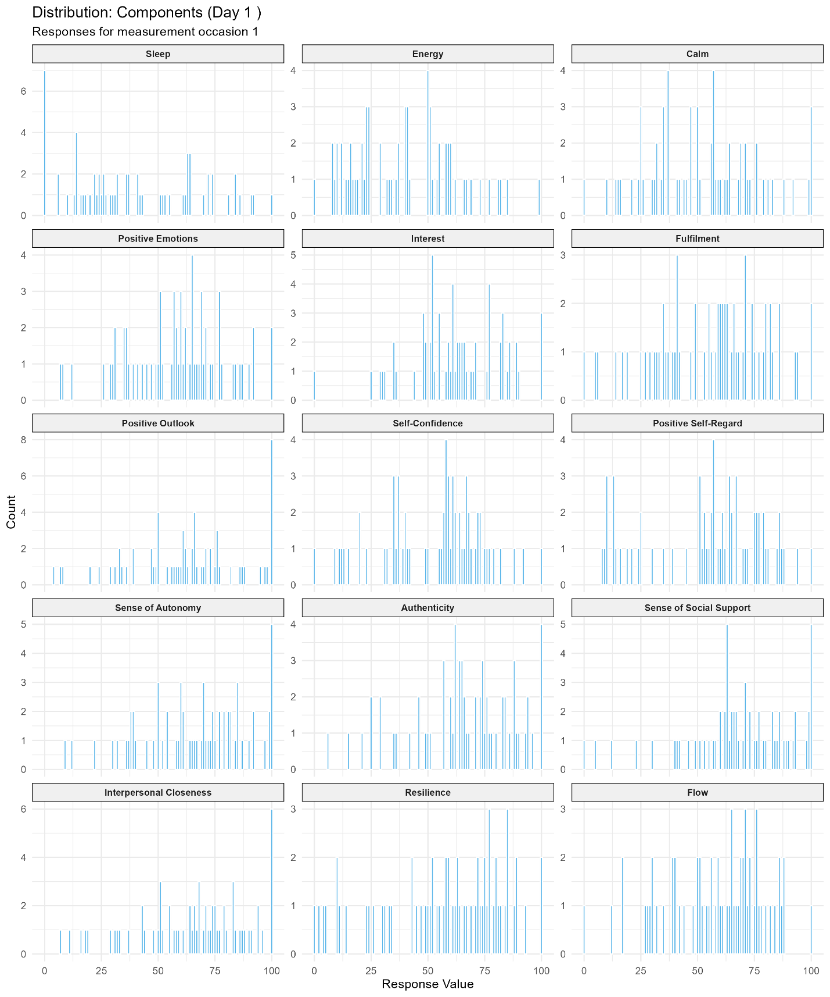
Figure D2
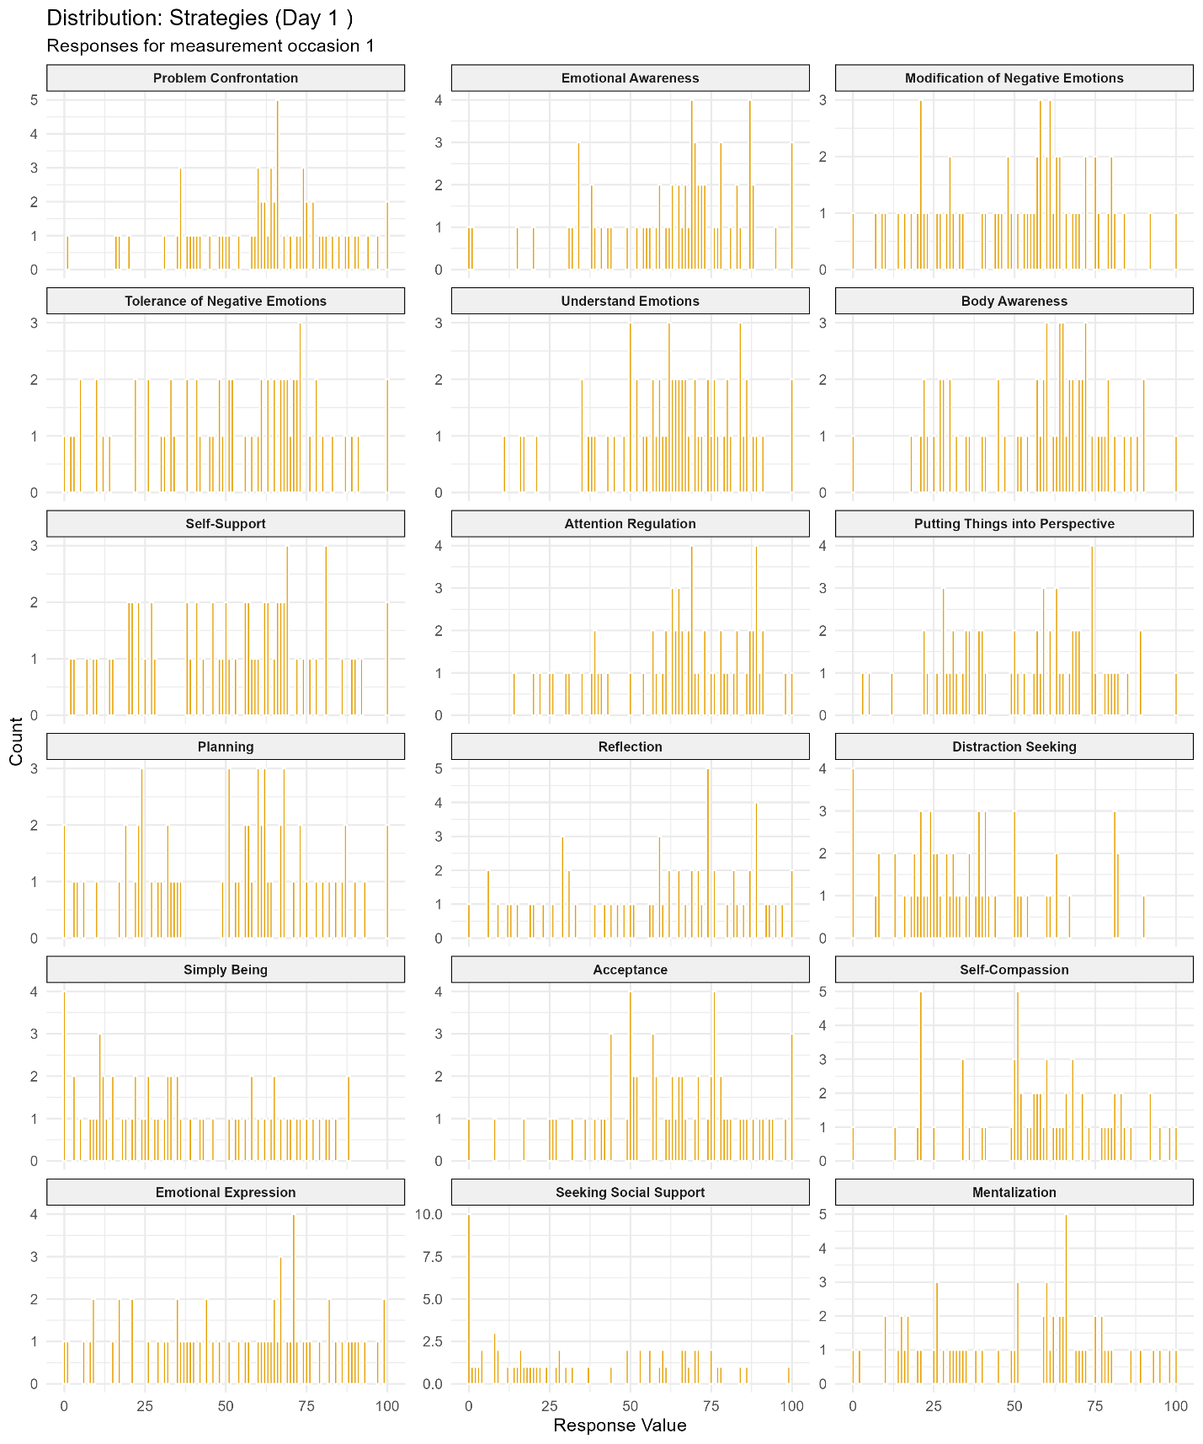

Figure D3
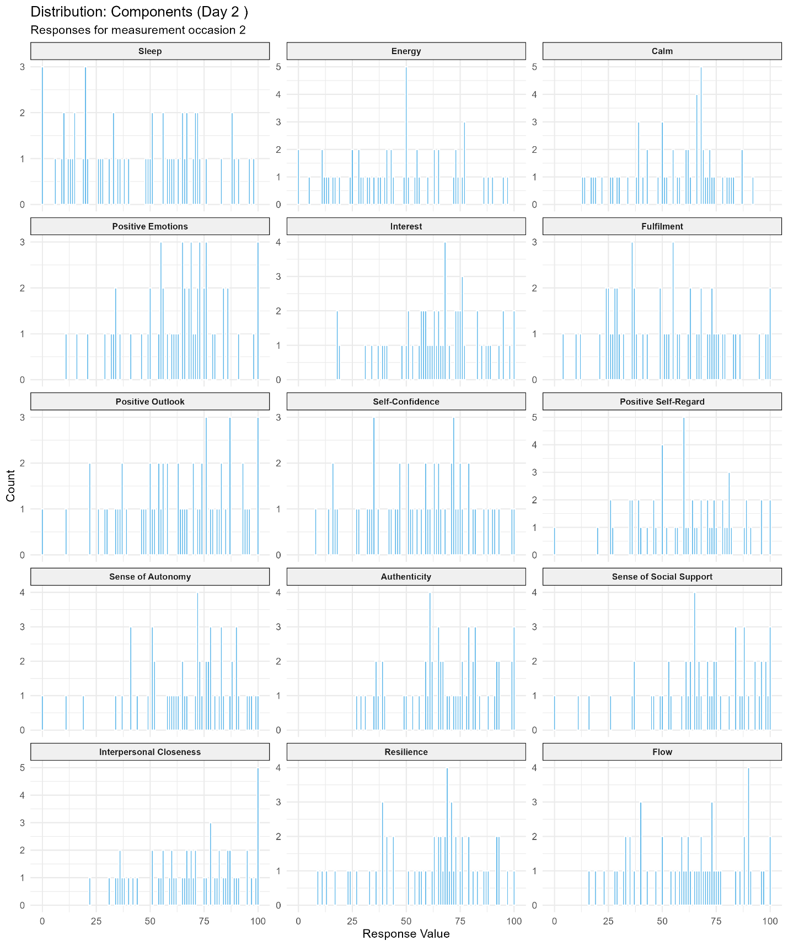

Figure D4
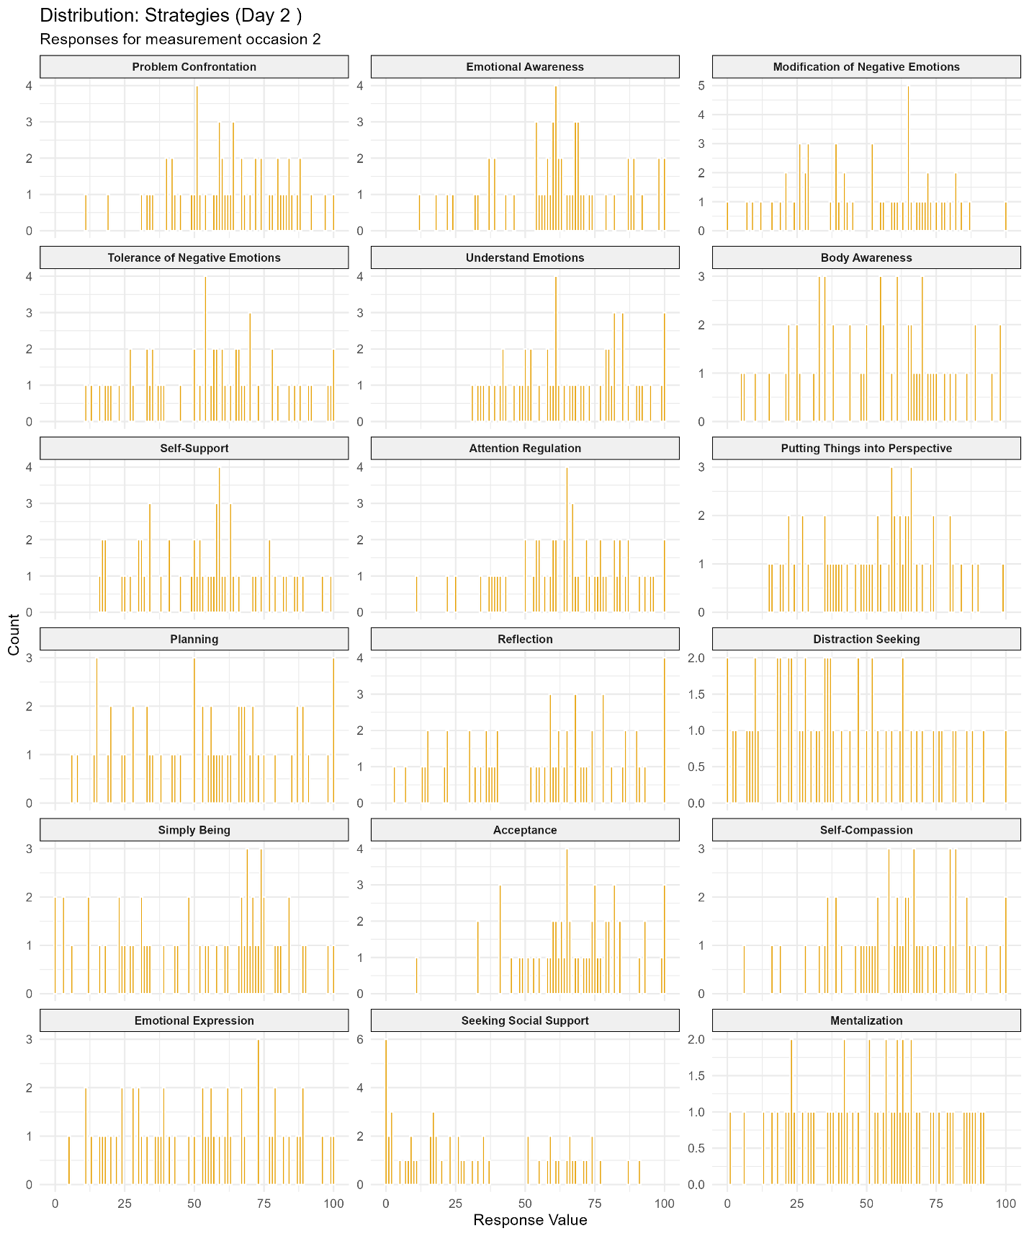

Figure D5
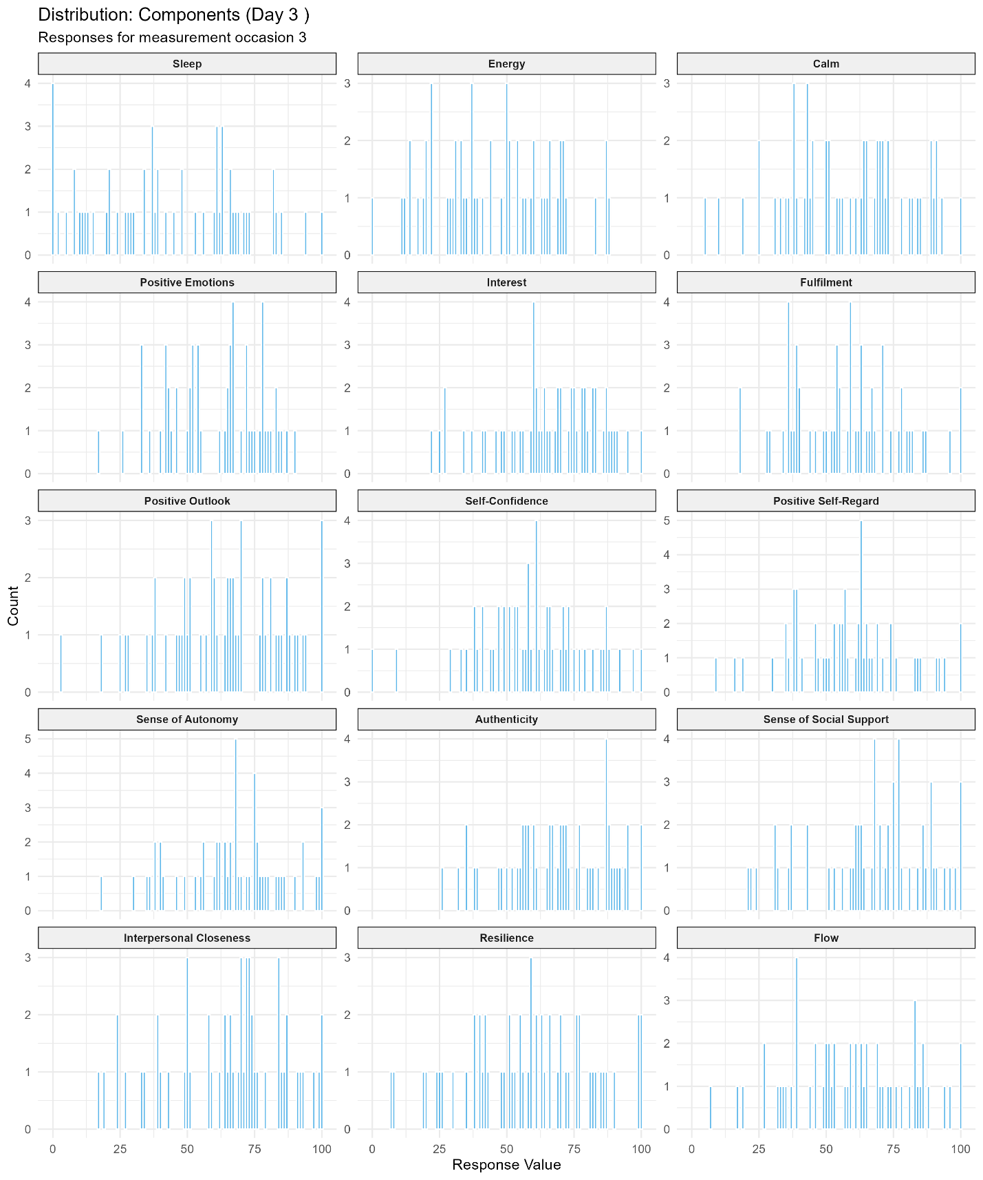

Figure D6
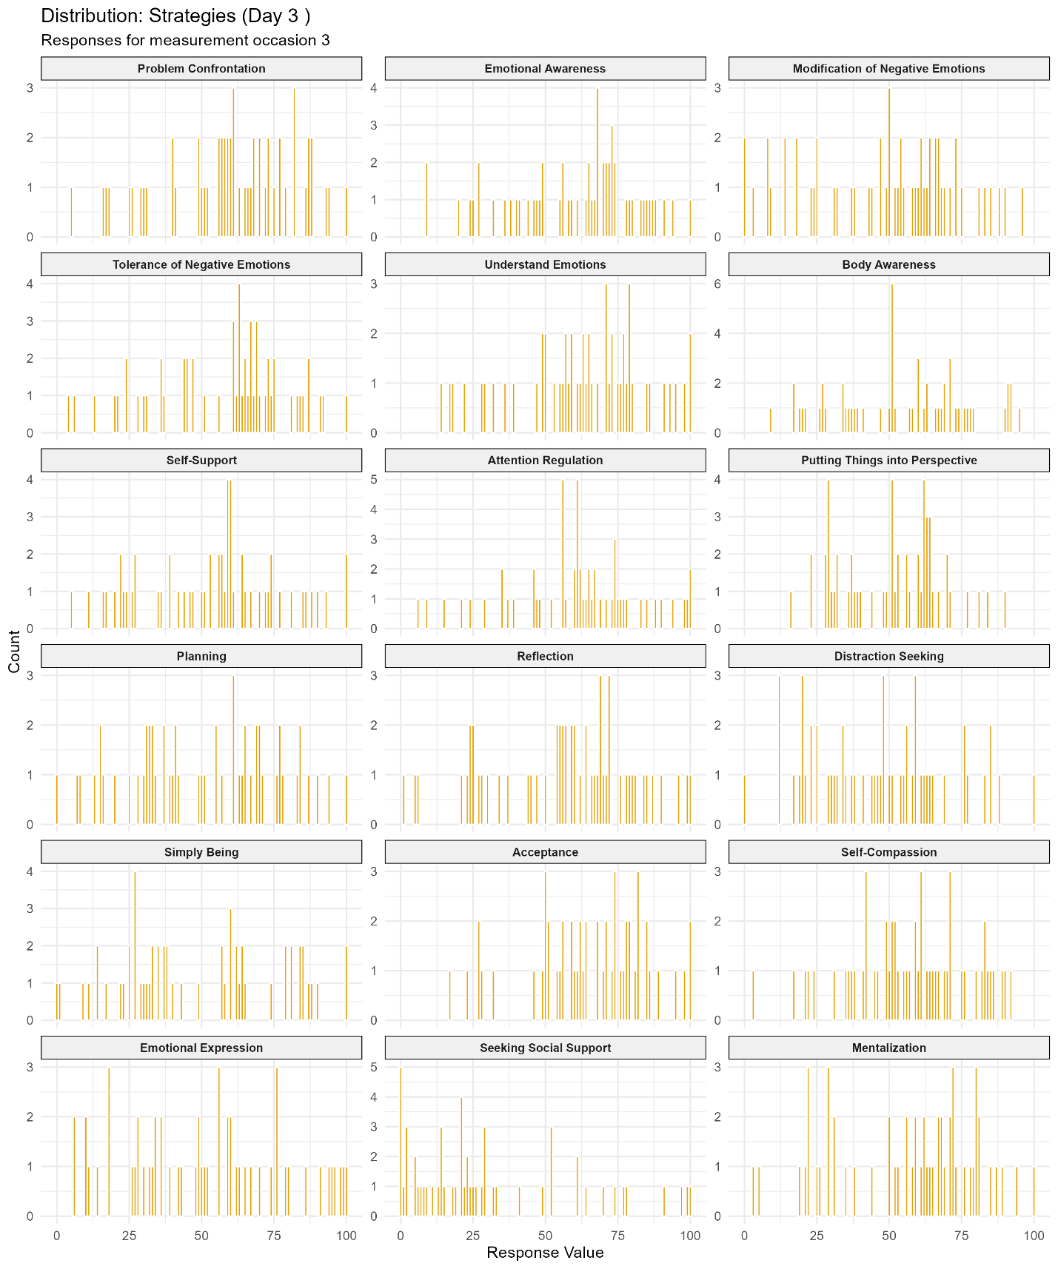

Figure D7
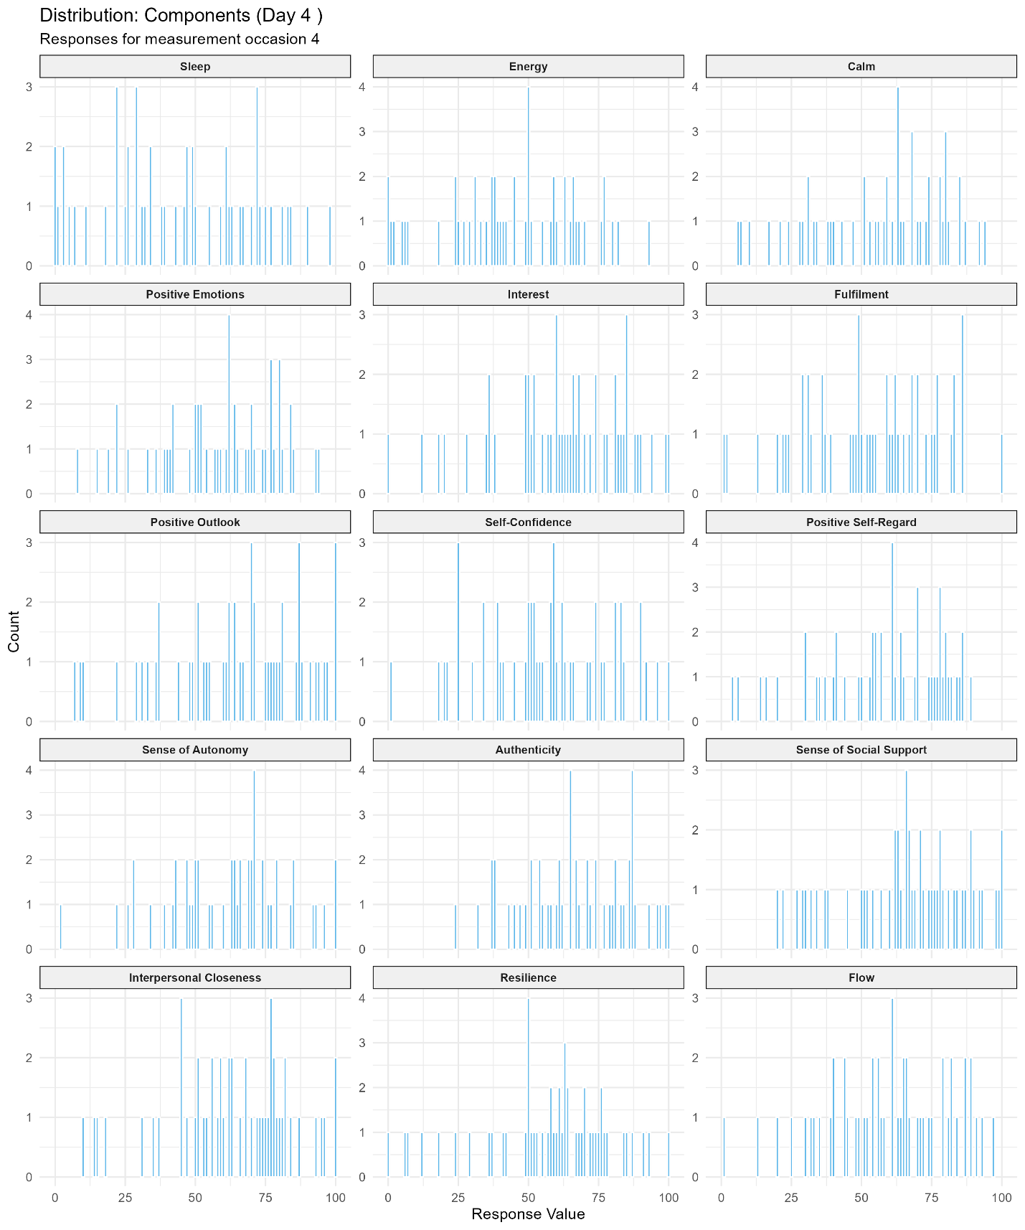

Figure D8
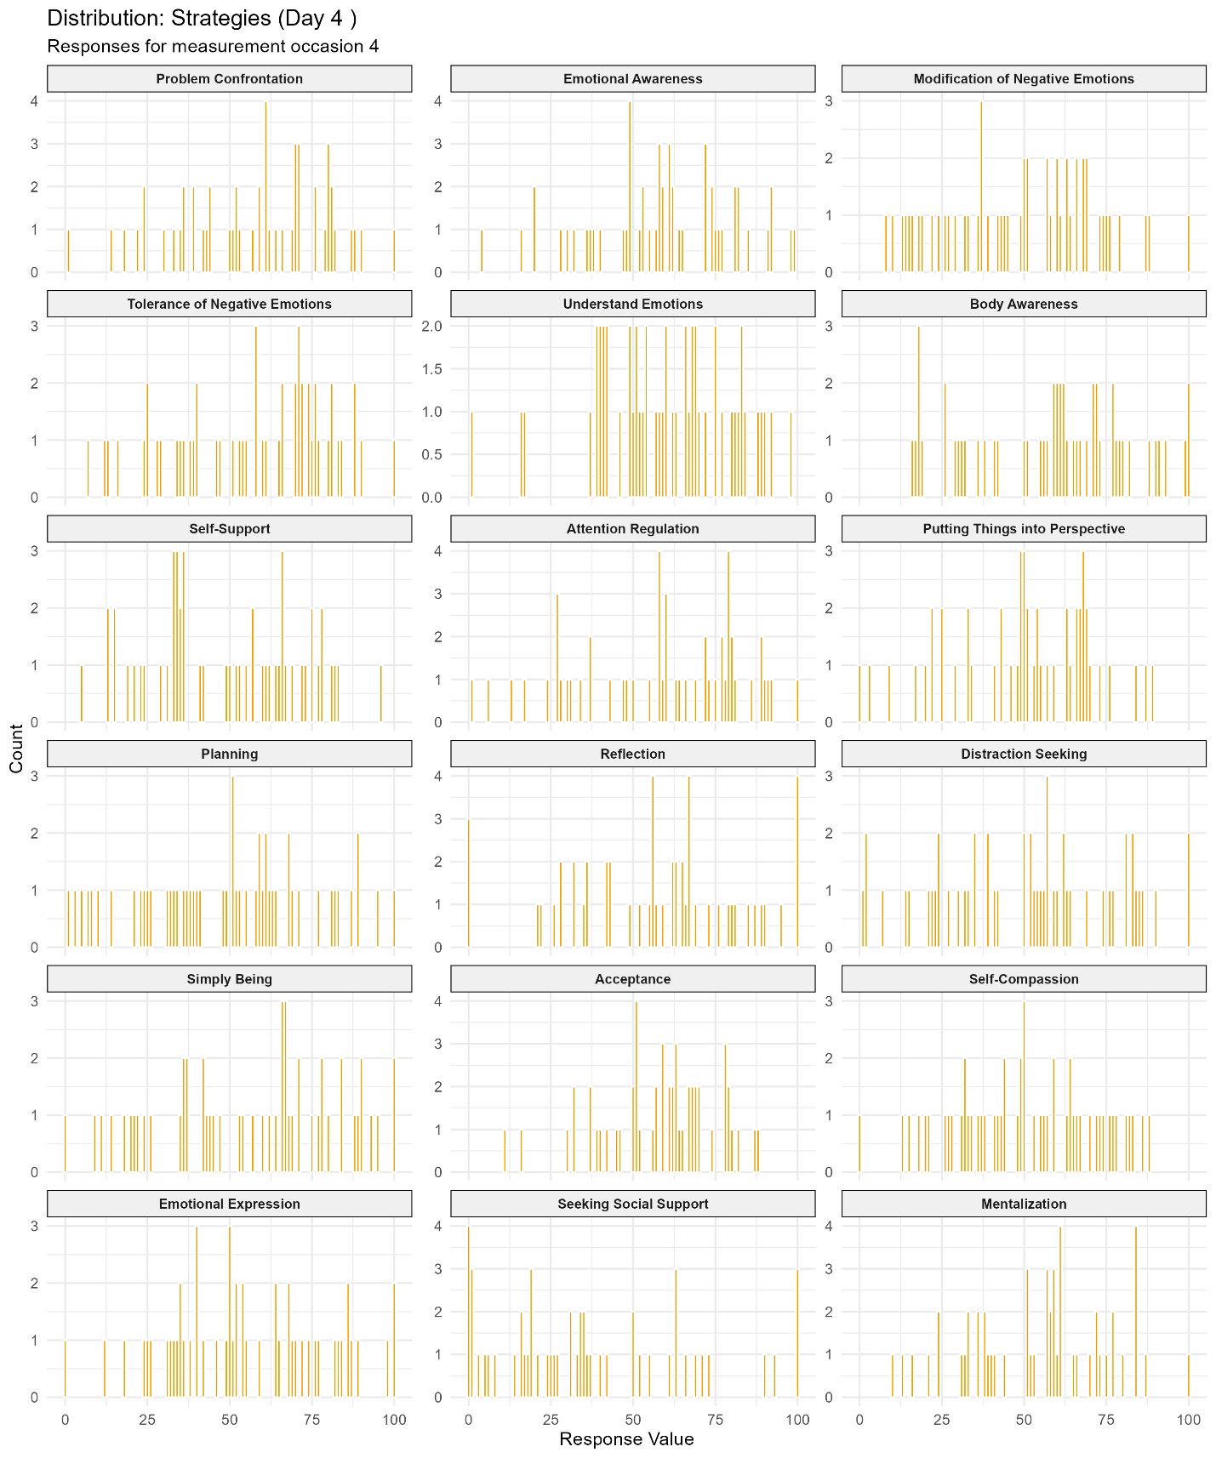

Figure D9
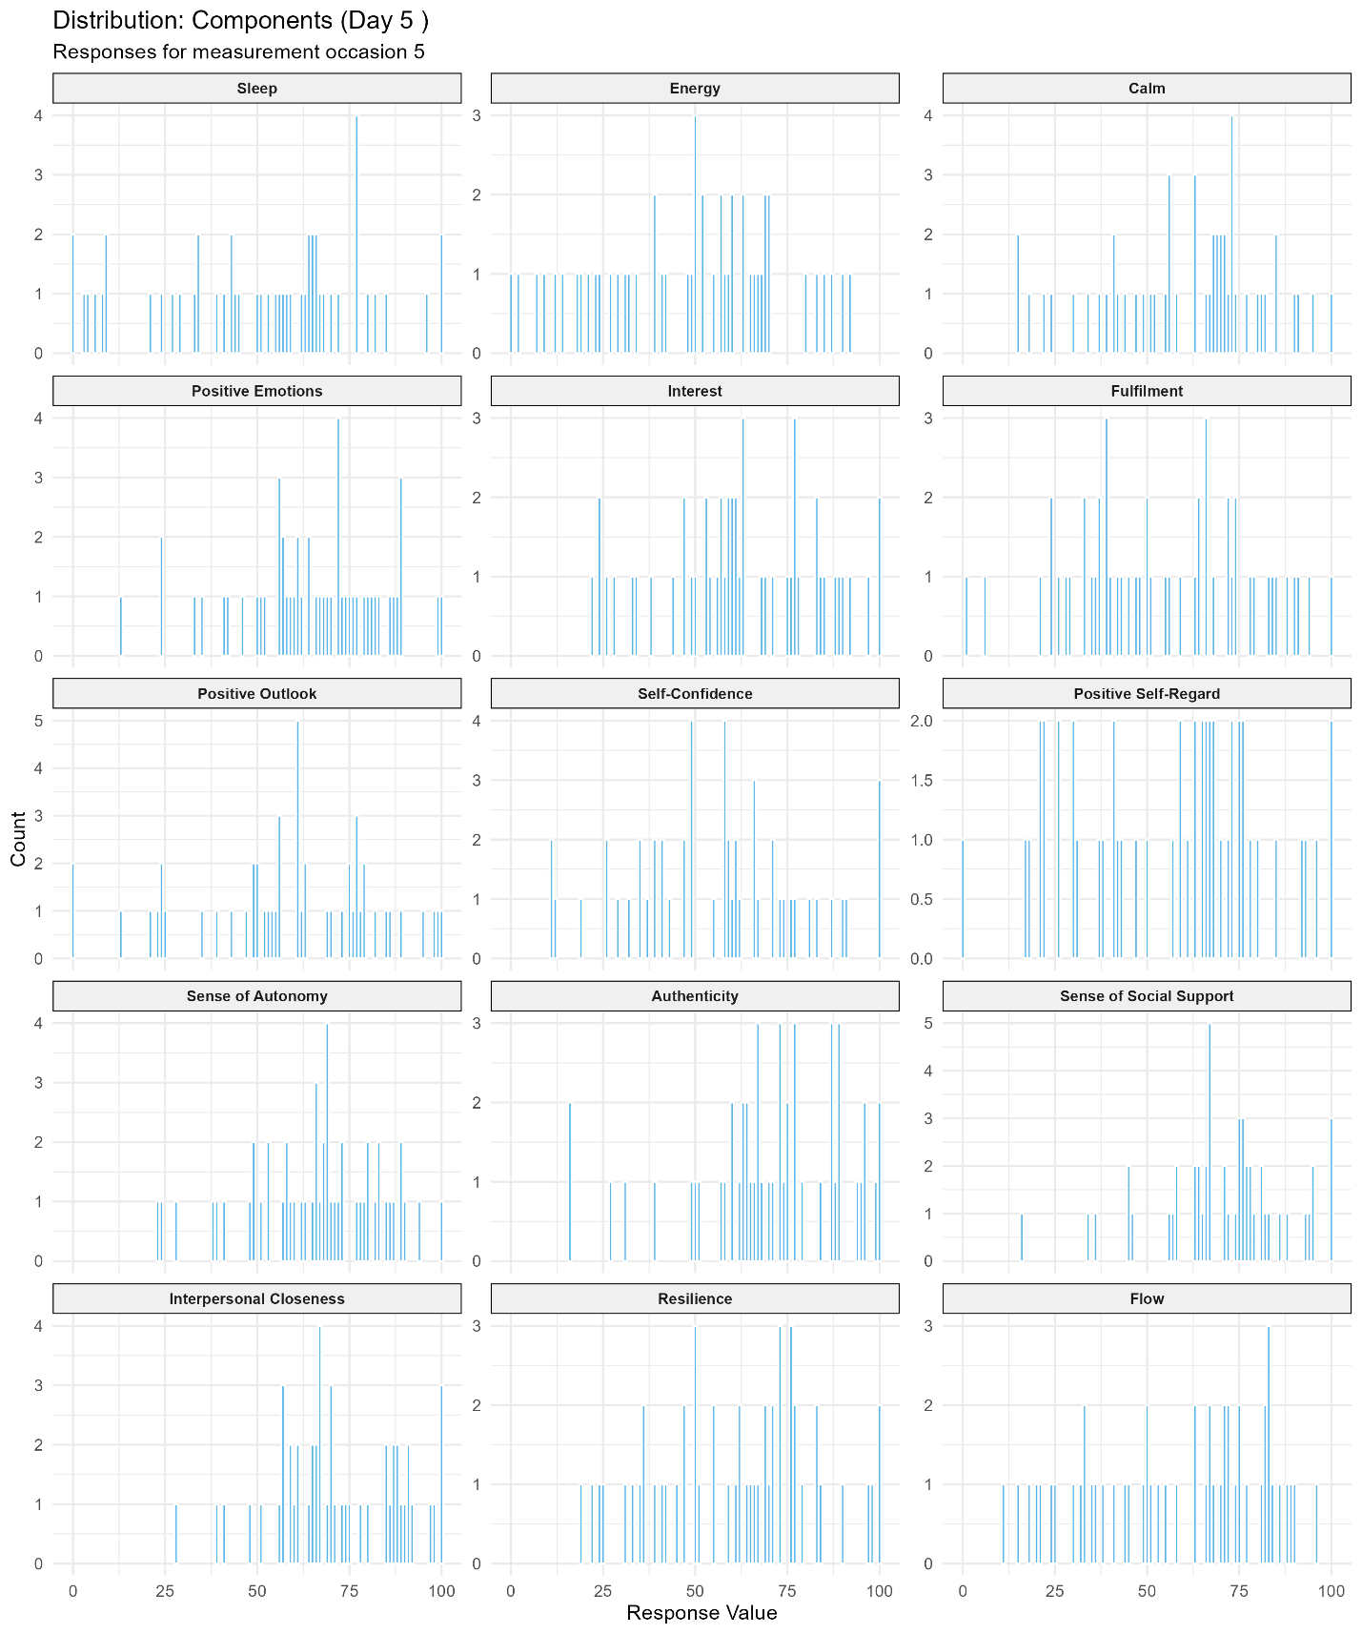

Figure D10
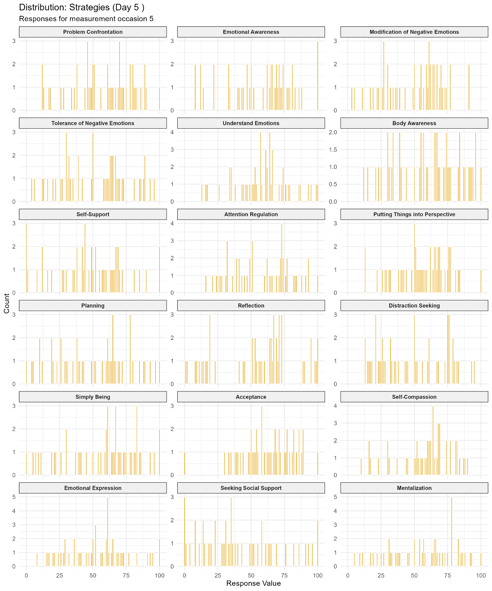

Figure D11
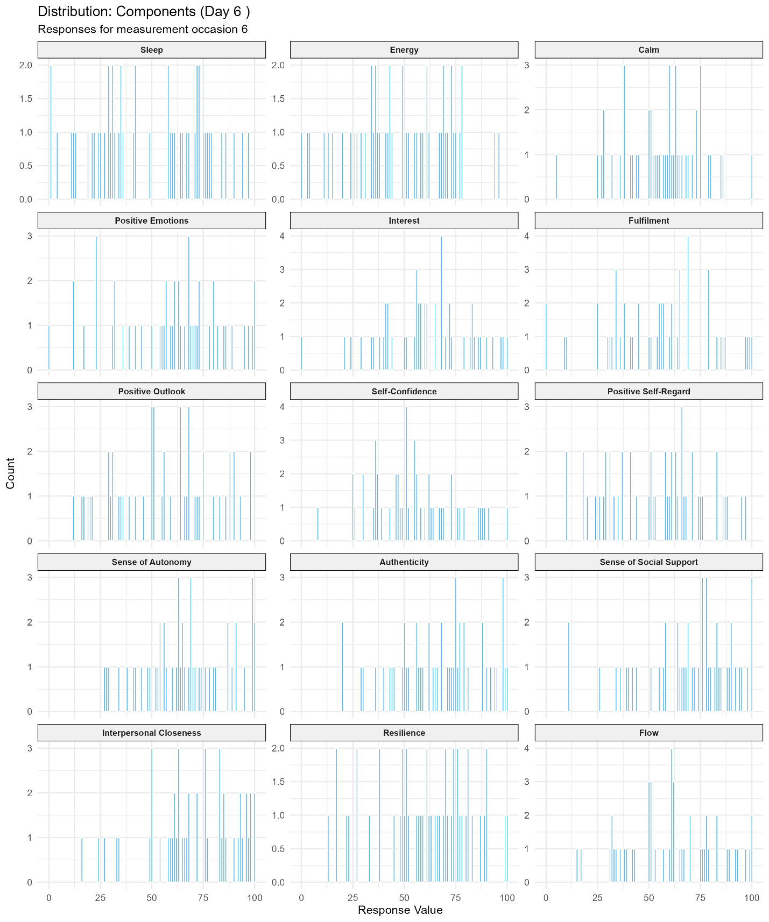

Figure D12
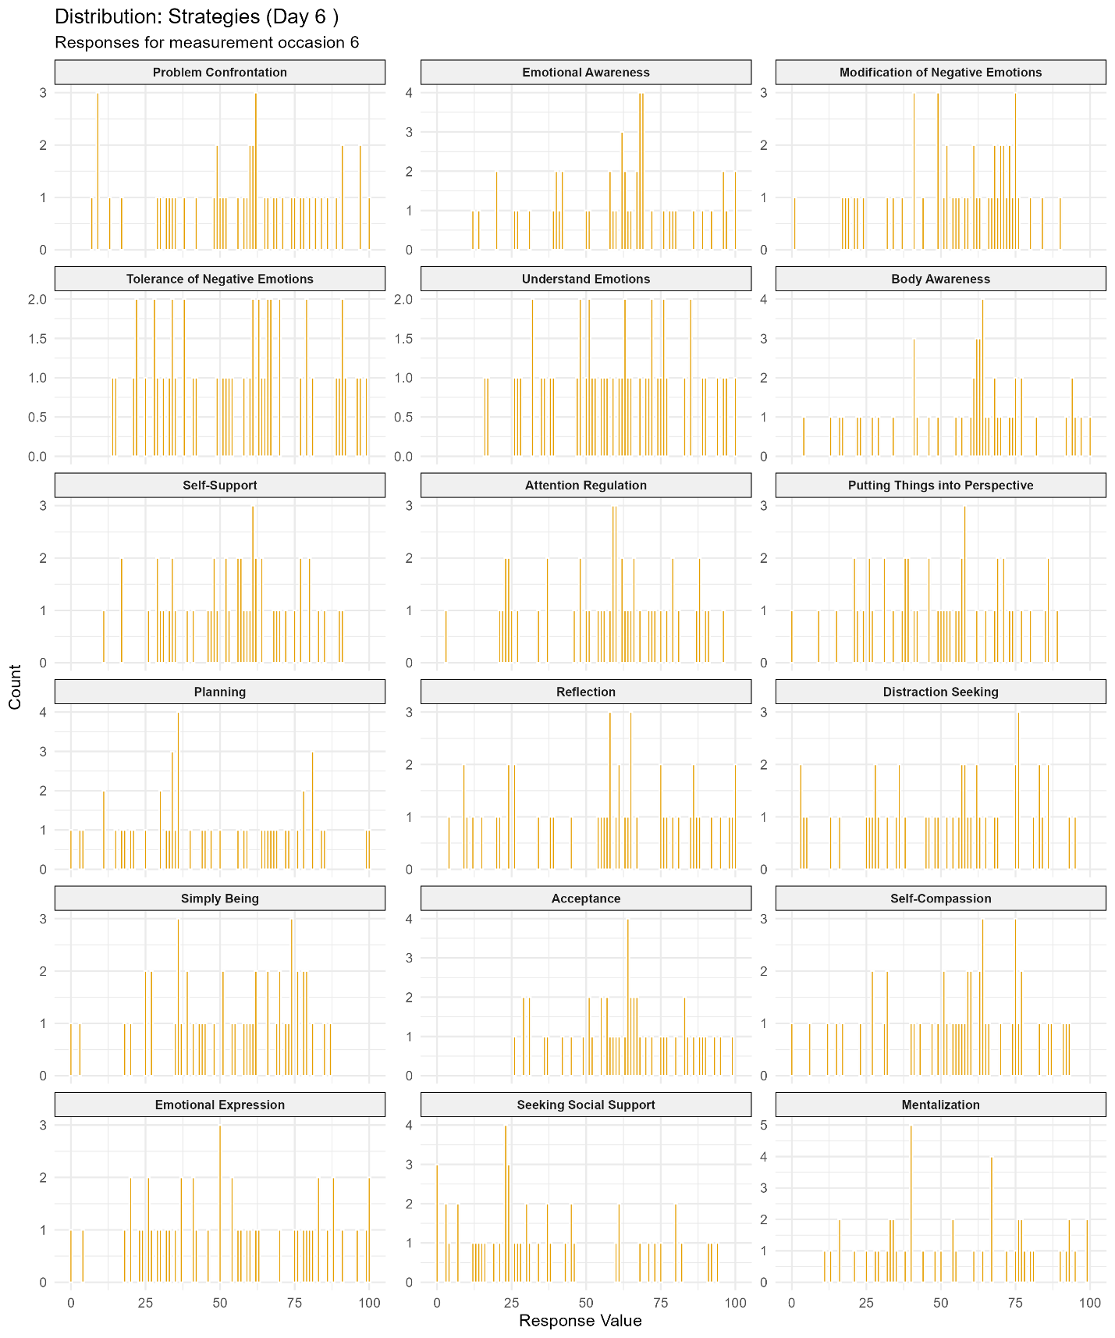

Figure D13
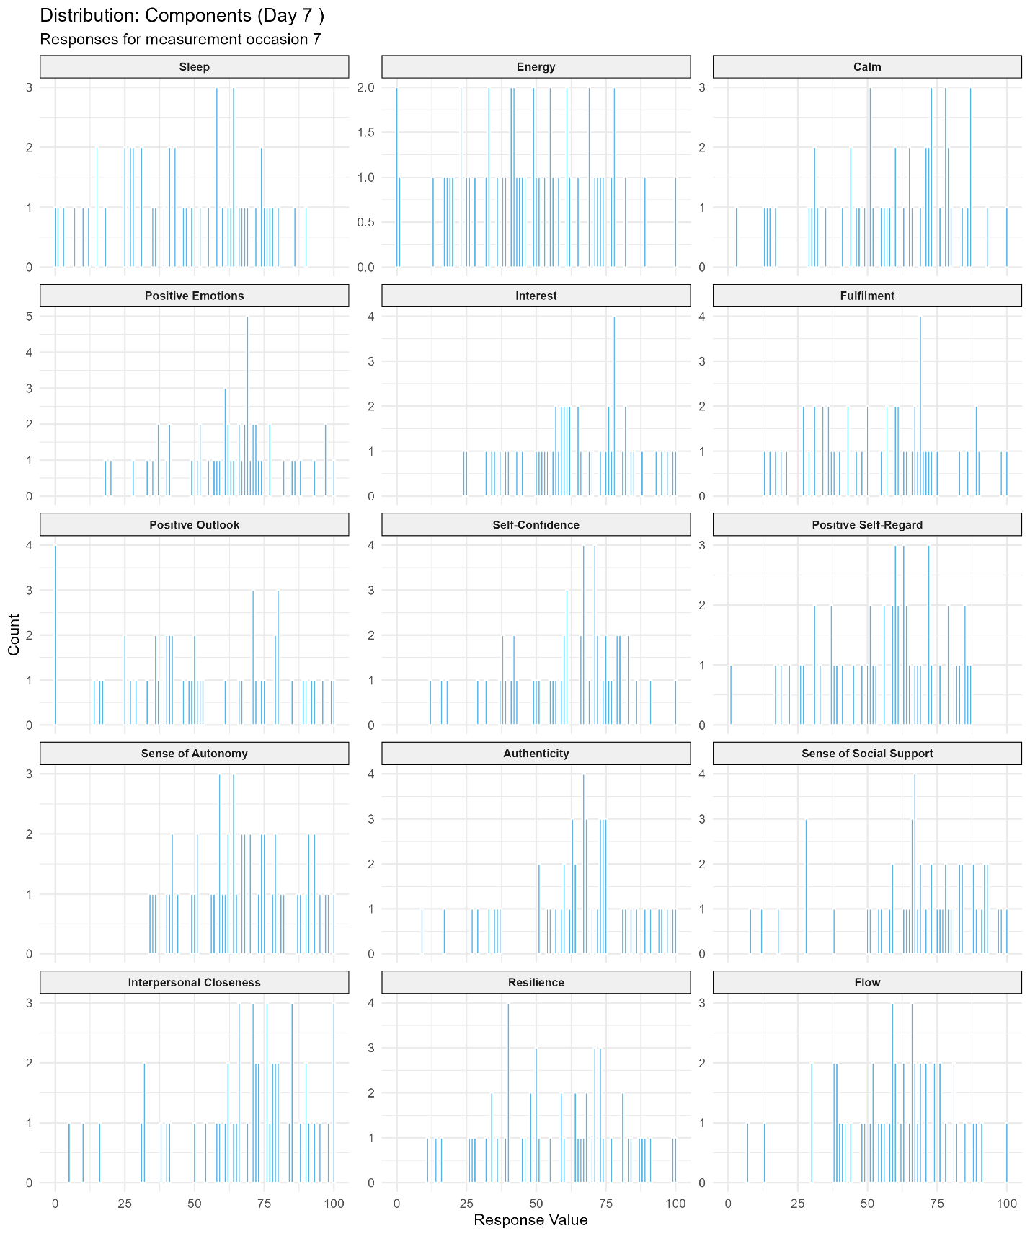

Figure D14
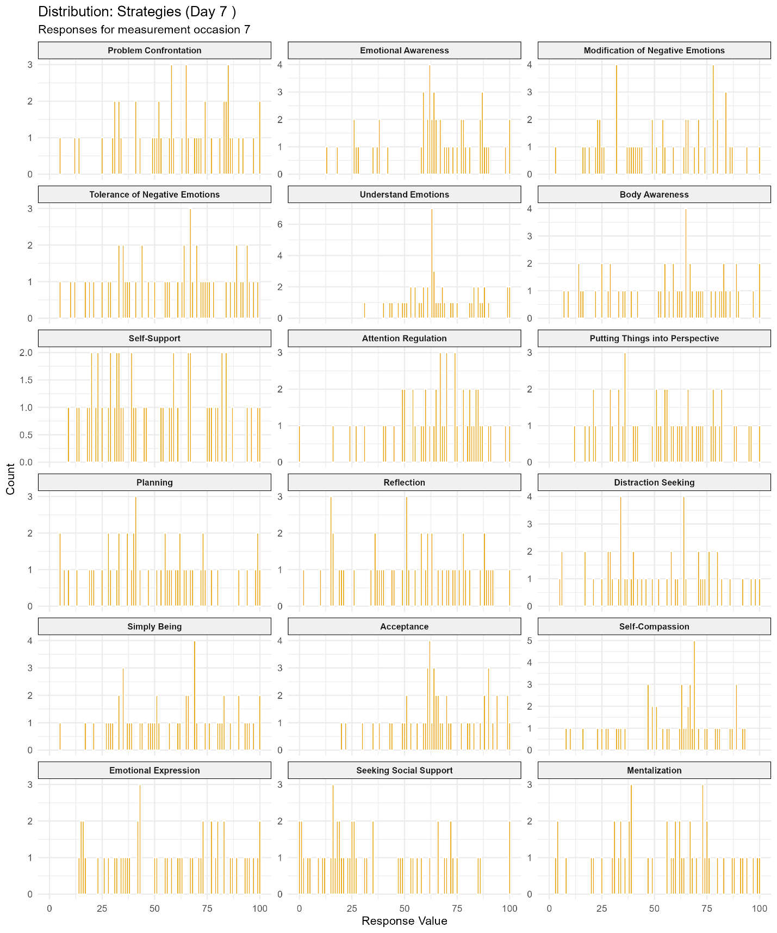

Online Supplement E. Exploratory Example Analysis (N = 1)

Method
In this section, we present an illustrative profile of a single respondent who participated in all seven measurement occasions. Using data from Study 2, we randomly sampled an eligible participant (here, Participant 107) and calculated descriptive statistics for both their item responses. Additionally, we computed lag-1 autocorrelations for each item. To visualize these dynamics, we generated lollipop plots for each item, displaying the individual responses at each measurement occasion alongside the items’ means.

Results
Table E1 provides an overview of participant’s descriptive statistics and item-level autocorrelations. Notably, estimates derived from only seven measurement points are inherently unstable; thus, they are presented here solely to demonstrate how such profiles might appear over a longer observation period.
The participant completed all measurements with no missing data. They utilized a restricted range of the scale, avoiding extreme responses (e.g., scores ranged from 8 to 91). As illustrated by both plots (Figure E1 and E2) and standard deviations, fluctuations were relatively subtle for certain items, such as Calm and Social Support. In contrast, items like Sleep, Problem Confrontation, and Self-Confidence exhibited more volatile fluctuations. It should be noted, however, that in cases like Simply Being, this observed volatility may be partially attributed to borderline reliability.

Table E1
Descriptive Statistics for Participant 107
Category | Item | M | SD | Md | Min | Max | AR1
Component | Sleep | 39.71 | 26.41 | 41 | 8 | 66 | .50
Component | Energy | 44.71 | 13.84 | 48 | 22 | 58 | -.09
Component | Calm | 49.43 | 9.86 | 51 | 37 | 63 | -.27
Component | Positive Emotions | 62.86 | 18.34 | 64 | 31 | 85 | -.22
Component | Interest | 76.86 | 13.40 | 83 | 58 | 92 | .29
Component | Fulfilment | 69.43 | 17.80 | 71 | 36 | 91 | -.15
Component | Positive Outlook | 55.71 | 19.58 | 55 | 20 | 77 | .30
Component | Self-Confidence | 59.57 | 24.64 | 64 | 32 | 91 | -.17
Component | Positive Self-Regard | 72.00 | 22.52 | 81 | 29 | 94 | .10
Component | Sense of Autonomy | 67.00 | 12.46 | 68 | 49 | 83 | .02
Component | Authenticity | 67.00 | 15.59 | 65 | 44 | 87 | -.16
Component | Sense of Social Support | 55.29 | 15.37 | 58 | 31 | 71 | -.43
Component | Interpersonal Closeness | 58.00 | 22.55 | 62 | 24 | 81 | -.21
Component | Resilience | 58.14 | 22.55 | 66 | 17 | 77 | .16
Component | Flow | 72.00 | 22.92 | 83 | 31 | 90 | .35
Strategy | Problem Confrontation | 67.14 | 28.68 | 82 | 9 | 90 | .03
Strategy | Emotional Awareness | 61.57 | 20.64 | 68 | 20 | 86 | -.36
Strategy | Modification of Negative Emotions | 52.14 | 15.64 | 60 | 26 | 69 | .28
Strategy | Tolerance of Negative Emotions | 57.71 | 17.09 | 61 | 28 | 84 | -.28
Strategy | Understand Em | 74.29 | 14.37 | 71 | 57 | 93 | -.29
Strategy | Body Awareness | 59.57 | 16.89 | 65 | 25 | 78 | -.24
Strategy | Self-Support | 66.00 | 16.16 | 68 | 50 | 96 | -.26
Strategy | Attention Regulation | 73.00 | 18.92 | 78 | 34 | 91 | -.38
Strategy | Putting Things into Perspective | 51.86 | 17.48 | 58 | 28 | 76 | -.33
Strategy | Planning | 43.14 | 24.17 | 56 | 14 | 68 | -.21
Strategy | Reflection | 34.29 | 17.11 | 32 | 12 | 58 | .21
Strategy | Seeking Distraction | 35.00 | 17.99 | 32 | 15 | 69 | -.26
Strategy | Simply Being | 48.00 | 31.09 | 48 | 10 | 93 | .31
Strategy | Acceptance | 71.00 | 12.58 | 74 | 55 | 88 | -.07
Strategy | Self-Compassion | 72.71 | 17.60 | 81 | 42 | 93 | -.29
Strategy | Emotional Expression | 59.00 | 20.63 | 65 | 18 | 77 | -.37
Strategy | Seeking Social Support | 20.14 | 5.93 | 18 | 14 | 29 | -.24
Strategy | Mentalization | 44.14 | 24.98 | 57 | 15 | 73 | .78

Figure E1
Fluctuation around means of component items (Participant 107)
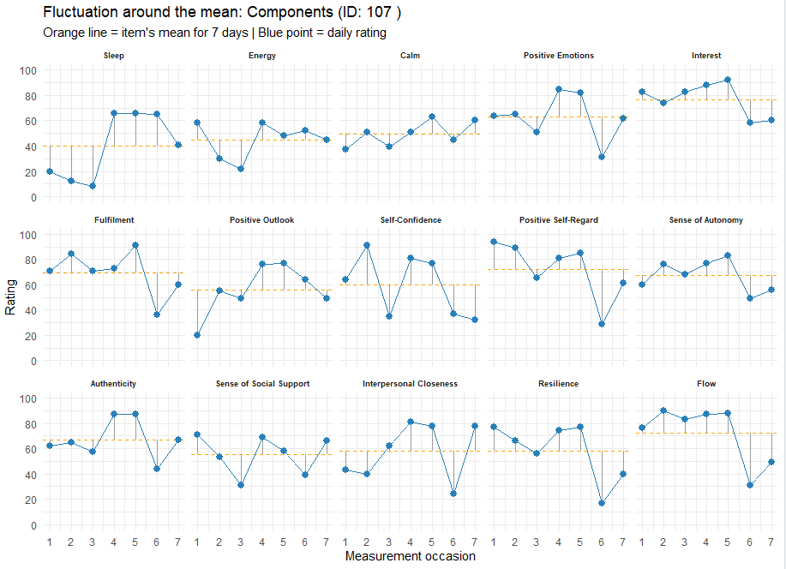
Figure E2
Fluctuation around means of strategies items (Participant 107)
